**B.Write the animal's name.(15 points)**

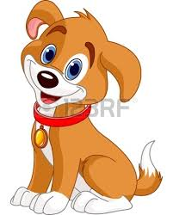 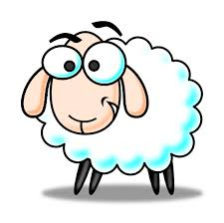 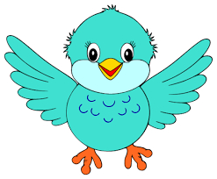 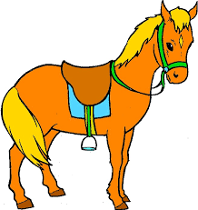 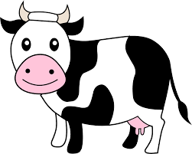

_____________ _____________ _____________ _____________ _______________

**C. Match the sentences with the pictures.(15 points)**





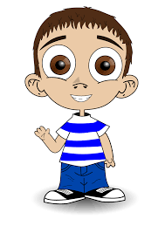

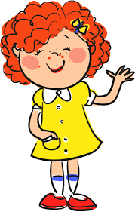



* jjjjjjjj

I want a doll.

I want a train.

I want a teddy bear.

I want marbles.

I want a kite.

**FINAL EXAM**

**FULL NAME:**

**FINAL EXAM**

**FINAL EXAM**

**FULL NAME:**

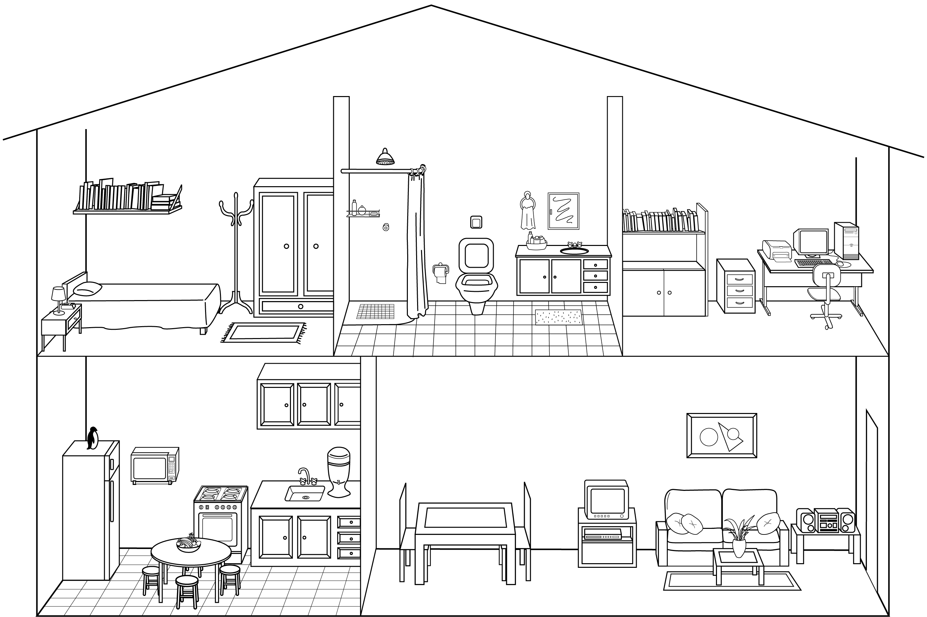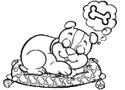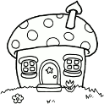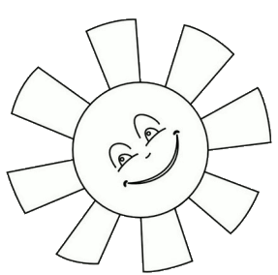

1. **Unscramble the words and write their numbers on the home parts. (20points)**

1. iilvng oorm: ________________

2. deborom: _________________

3. kictent: ____________________

4. inidng ormo: ________________

5. btahorom: _________________

**E)Matches the pictures correct answer. (15 points)**

1.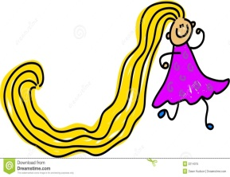 2. 3. 4.

5.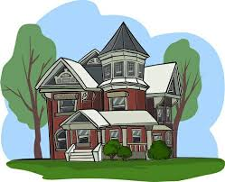 6.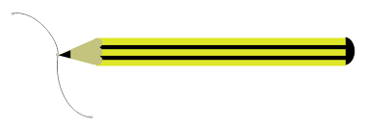 7.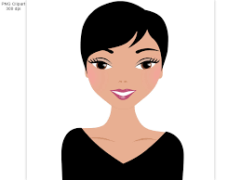 8. 

1. Small pencils ( ) e) Long hair ( )
2. Short hair ( ) f) Small house ( )
3. Big house ( ) g) Small stars ( )
4. Big heart ( ) h) Long pencil ( )

**F. Write the words in Turkish.(10 points)**

a. eraser:_______________

b. orange: ______________

c. square: ______________

d. finger: _______________

e. jacket: _______________

**D. Choose the correct option.(25 points)**

1. What is he doing?

a. He is doing sack race.

b. He is scating.

c. He is playing soccer.

1. What are they doing?

a. They are playing hide&seek.

b.They are playing hopscotch.

c. They are playing blind man's buff.

1. What are they doing?

a. They are playing hide &seek.

b. They are jumping rope.

c. They are playing tennis.

1. What is she doing?

a. She is playing volleyball.

b. She is playing hide&seek.

c. She is playing hopscotch.

1. What is he doing?

a. He is playing soccer.

b. He is playing hopscotch.

c. He is jumping rope.

1. Where is she?

a. She is under the bed.

b. She is on the bed.

c. She is in the bed.

1. Where is the ball?

a. It is under the table.

b.It is on the table.

c.It is in the box.

1. Where are the cats?

a. They are in the box.

b.They are under the table.

c. They are on the chair.

.

