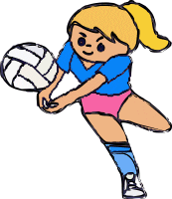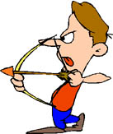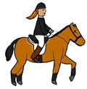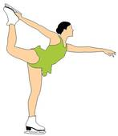

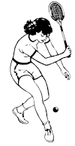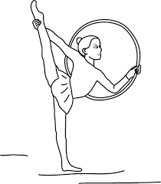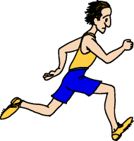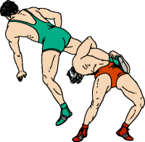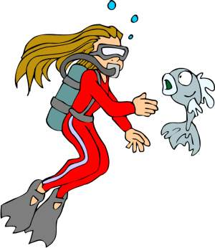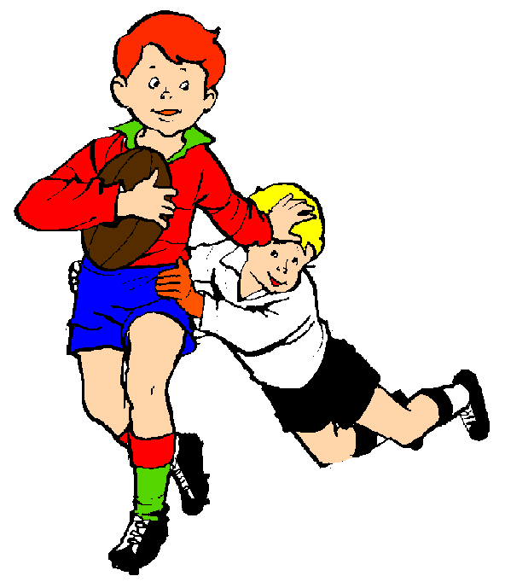

|  |  |  |  |  |  |  |  |  |  |  |  |  |  |  |
| --- | --- | --- | --- | --- | --- | --- | --- | --- | --- | --- | --- | --- | --- | --- |
|  |  |  |  |  | 1 |  |  |  |  |  |  |  |  |  |
|  |  |  | 2 |  |  |  |  |  |  |  |  |  |  |  |
| clipart_karate |  |  |  | 3 |  |  |  |  |  |  |  |  |  |  |
|  |  |  | 4 |  |  |  |  |  |  |  |  |  |  |  |
|  |  |  |  |  |  |  |  |  | 5 |  |  |  |  |  |
|  |  |  |  | 6 |  |  |  |  |  |  |  |  |  |  |
|  |  |  | 7 |  |  |  |  |  |  |  |  |  |  |  |
|  |  |  |  |  |  |  |  | 8 |  |  |  |  |  |  |
|  |  |  |  |  |  |  |  |  |  | 9 |  |  |  |  |
|  |  | cyclist_female |  |  |  |  |  |  |  | 10 |  |  |  |  |
|  |  |  |  |  |  |  |  |  |  | 11 |  |  |  |  |
|  |  |  |  |  |  |  |  |  |  |  |  | 12 |  |  |
|  |  |  |  |  | 13 |  |  |  |  |  |  |  |  |  |
|  |  |  |  |  |  |  | 14 |  |  |  |  |  |  |  |
|  |  |  |  |  | 15 |  |  |  |  |  |  |  |  |  |
|  |  |  |  |  |  |  |  |  | 16 |  |  |  |  |  |

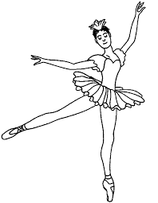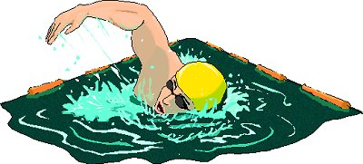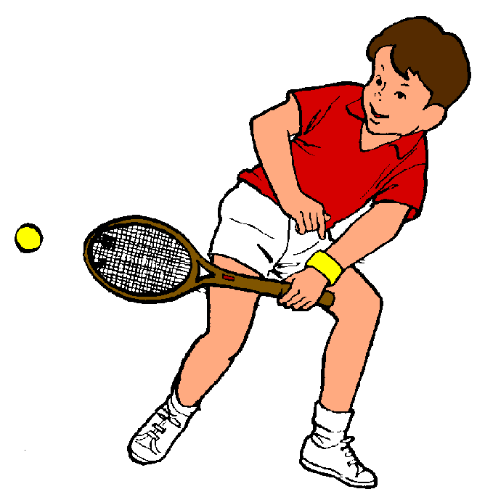

|  |  |  |  |  |  |  |  |  |  |  |  |  |  |  |  |
| --- | --- | --- | --- | --- | --- | --- | --- | --- | --- | --- | --- | --- | --- | --- | --- |
|  |  |  |  |  |  |  | P | L | A | N | C | H | E |  |  |
|  |  |  |  |  | T | I | R | A | L | A | R | C |  |  |  |
|  |  |  |  |  |  | D | A | N | S | E |  |  |  |  |  |
|  |  |  |  |  | P | A | T | I | N | A | G | E |  |  |  |
|  |  | N | A | T | A | T | I | O | N |  |  |  |  |  |  |
|  |  |  |  |  |  | S | Q | U | A | S | H |  |  |  |  |
|  |  |  |  |  | E | Q | U | I | T | A | T | I | O | N |  |
|  |  |  | V | O | L | L | E | Y |  |  |  |  |  |  |  |
|  |  |  |  |  | K | A | R | A | T | E |  |  |  |  |  |
|  |  |  |  |  | C | O | U | R | S | E |  |  |  |  |  |
|  |  |  |  |  | T | E | N | N | I | S |  |  |  |  |  |
|  |  | G | Y | M | N | A | S | T | I | Q | U | E |  |  |  |
|  |  |  |  |  |  |  | P | L | O | N | G | E | E |  |  |
|  |  |  |  | V | E | L | O |  |  |  |  |  |  |  |  |
|  |  |  |  |  |  |  | R | U | G | B | Y |  |  |  |  |
|  |  |  |  |  | L | U | T | T | E |  |  |  |  |  |  |