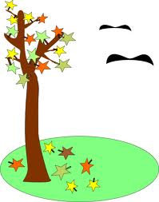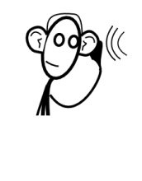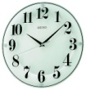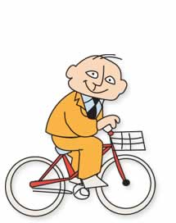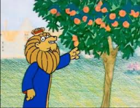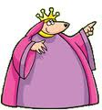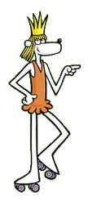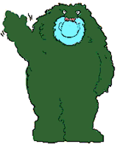

What’s your score? ________/22.

**Circle your answers in the boxes! Have fun!**

22. What’s the season?

a) spring

b) summer

c) autumn

21. How does he feel?

a) cold

b) warm

c) scorching

20. Which number follows twelve?

a) three

b) thirteen

c) thirty

19. Where is the mouse?

a) behind

b) next to

c) in front of

18. Where am I from?

a) Finland

b) Greece

c) Portugal

17. How many letters has the English alphabet?

a) 26

b) 27

c) 28

16. What day follows Wednesday?

a) Friday

b) Tuesday

c) Thursday

14. What time is it?

a) ten to ten

b) ten past ten

c) ten sharp

15. What is he doing?

a) talking

b) speaking

c) listening

13. Where is the biker with a black, red, and yellow flag from?

a) France

b) Spain c) Germany

12. Who are in love with Sylvia?

a) Corvax and Muzzy

b) Muzzy and Bob

c) Bob and Corvax

11. Norman rides

a) a scooter

b) a bike

c) a motorcycle

10. Bob and Muzzy are in

a) cell # 19

b) cell # 9

c) cell # 90

9. Sylvia lives in a

a) house

b) cabin

c) castle

8. The queen is

a) fast

b) unhappy

c) fat

7. Bob is

a) beautiful

b) brave

c) blond

6. Muzzy’s favourite dish is

a) parking meters

b) metal bars

c) clocks

5. The King likes

a) oranges

b) plums

c) apples

4. Bob is

a) a gardener

b) a biker

c) a vendor

3. Corvax is

a) a motorbike

b) a police officer

c) a scientist

2. Sylvia is

a) a cat

b) a princess

c) a queen

1. Muzzy is from

a) Rotondoland

b) Orlandoland

c) Gondoland