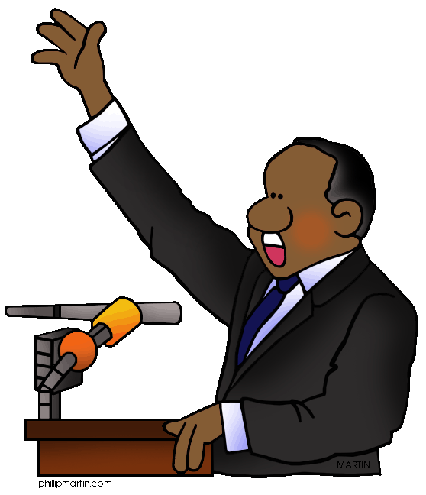

|  |  |  |  |  |
| --- | --- | --- | --- | --- |
| **1** | **Obama** | **Gandhi** | **Mandela** | **Armstrong** |
| **2** | **Huron** | **Michigan** | **Erie** | **Victoria** |
| **3** | **Cree** | **Cheyenne** | **Aborigine** | **Blackfoot** |
| **4** | **Amish** | **Creek** | **Mennonites** | **Hutterites** |
| **5** | **Ann Oakley** | **Bill Picket** | **Billy the Kid** | **Ned Kelly** |
| **6** | **Yellowstone** | **Yosemite** | **Joshua Tree** | **Death Valley** |
| **7** | **spruce** | **douglas** | **maple** | **fir** |
| **8** | **Alabama** | **Alaska** | **Florida** | **Alberta** |
| **9** | **Toronto Blue Jays** | **Phoenix Sun** | **Los Angeles Lakers** | **Orlando Magic** |
| **10** | **water** | **mountain dew** | **cola** | **root beer** |
| **11** | **McDonald’s** | **Wendy’s** | **Carl’s Jr** | **KFC** |
| **12** | **Barack Obama** | **Bill Clinton** | **George W Bush** | **Lance Armstrong** |

You see four words in each line. One word doesn’t go with the rest for some reason. You have to spot the odd one and highlight. There can be different reasons.

E.g.

Tooth – finger- foot –face (Here tooth is odd; the three other words begin with an F!

E

**ENGLISH** Y5-9 Intermediate