E
ENGLISH INTERMEDIATE

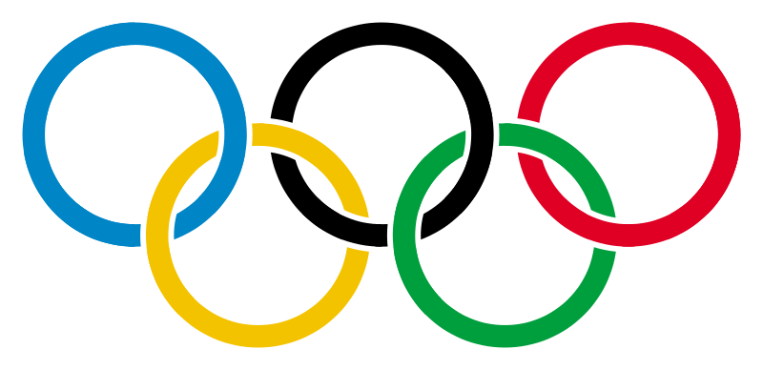
You see four words in each line. One word doesn’t go with the rest for some reason. You have to spot the odd one and highlight. There can be different reasons.
E.g.
Tooth – finger- foot –face (Here tooth is odd; the three other words begin with an F!

1 | Munich | London | New York | Sydney
2 | long jump | 100 metres | javelin | football
3 | 1980 | 1972 | 1985 | 2012
4 | Citius | Altius | Fortius | Longius
5 | handball | football | vollayball | squash
6 | platin | silver | bronze | gold
7 | Summer Games | Paralympics | Winter Games | Autumn Games
8 | Olympic dish | Olympic flame | Olympic flag | Olympic torch
9 | Africa | The Americas | Oceania | Asia
10 | Denmark | Bolivia | France | Spain
11 | Carl Lewis | Pierre de Coubertin | Mark Spitz | Jackie Joyner
12 | Sports | Competition | Environment | Culture

Answers (comments):
- New York never hosted the games
- Football is not one of the disciplines that make up the athletics
- 1985 is not an Olympic year
- Longius isn’t one of the words making up the motto of the games
- Squash is not an Olympic discipline
- Platin is not one of the metals of the medals you can win
- Autumn games
- Olympic dish is not a symbol of Olympic games
- The African continent never hosted the Olympics
- Bolivia never won a medal
- Pierre de Coubertin “invented” the modern games. The others are famous medal winners
- Competition is not one of the three pillars of the games.

