OUR HOLIDAY
Fill in the crossword.

 |  |  |  |  |  | 1 |  |  |  |  |  |  |  | 2
2
 |  |  |  |  |  | 3
 |  |  | 4
 |  |  |  | 5 |  |  |  |  |  |  |  |  | 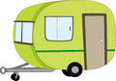
1 |  |  |  | 6
 |  |  |  |  |  |  | 7
 |  |  |  |  |  | 8 |  |  |  |  |  |  |  | 5
 | 3 |  |  |  |  | 9
 |  |  |  |  | 10
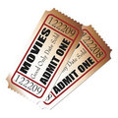 |  |  |  | 11
 |  |  |  |  |  | 12
 | 13
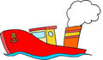
4
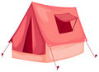
9

6
7
8

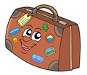
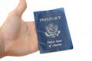
13
10
11
12

THE SOLUTION: WE HAD ____________________________________!
www.eegitimim.com

KEY

 |  |  |  |  |  | 1 | T | A | X | I
2 | S | W | I | M | M | I | N | G
 |  |  |  |  |  | 3 | T | R | A | I | N
 |  |  | 4 | T | I | C | K | E | T
 |  |  |  | 5 | C | A | R | A | V | A | N
 |  |  |  | 6 | T | E | N | T
 |  |  |  |  |  |  | 7 | H | O | T | E | L
 |  |  |  |  |  | 8 | B | O | A | T
 |  |  |  |  |  | 9 | P | L | A | N | E
 |  |  |  |  | 10 | S | U | I | T | C | A | S | E
 |  |  |  | 11 | W | E | D | D | I | N | G
 |  |  |  |  |  | 12 | P | A | S | S | P | O | R | T
 | 13 | T | R | O | L | L | E | Y

THE SOLUTION: WE HAD A GREAT HOLIDAY!

