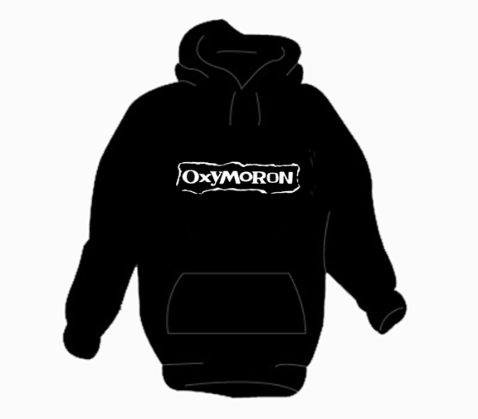
An OXYMORON is a figure speech that combines two normally contradictionary terms (”oxy” = sharp, ”moros” = dull)

ENGLISH –Intermediate / Advanced
Examples: a fine mess, almost always, found missing
COMBINE THE WORDS AND MAKE OXYMORONS

a fine mess
dead
fine

big
alone

done
almost

luck
adult

mess
ignorant

light
little

baby
Angels
nice
missing
classic
together
children
perfect
professor
invisible
awfully
appear
almost
Hell’s
black
bad
new
found
big
living

