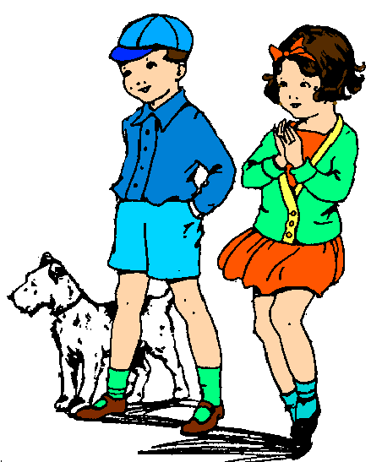

**N**

**Y**

Look at the pictures and read the sentences. Tick **✓** your answers in the **Y**ES or **N**O box.

2. The boy wears a blue cap and blue socks.

1. A boy and a girl are out walking a dog.

4. They look happy.

3. The girl wears an orange dress.

5. The dog is white with black stripes.

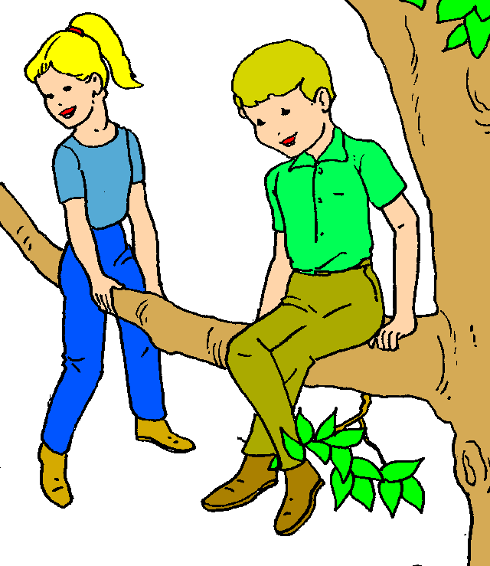

6. A girl and a boy are in the tree.

7. They are scared.

8. It is winter.

10. The girl has short hair.

9. They wear T-shirts, blue jeans and boots.

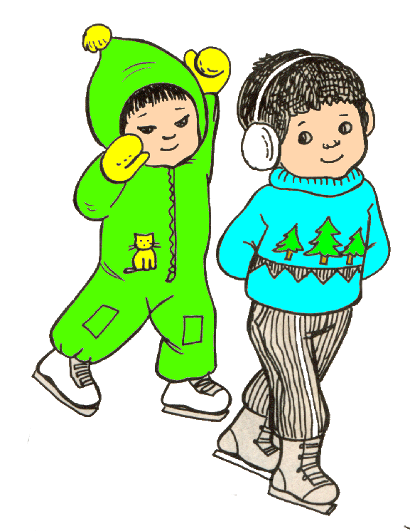

12. One boy is wearing a sweater.

11. Two kids are out skating.

14. The boy with a sweater is on the left.

13. One boy has white, curly hair.

homework@live.dk

16. One boy is wearing ear muffs.

15. Both boys are showing their hands.