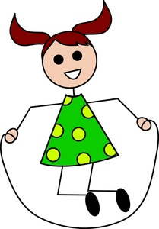

**N**

**Y**

Look at the pictures and read the sentences. Tick **✓** your answers in the **Y**ES or **N**O box.

2. She has brown hair.

1. The girl is wearing a dotted dress.

4. She is unhappy.

3. She jumps rope.

5. Her hair is in a pony tail.

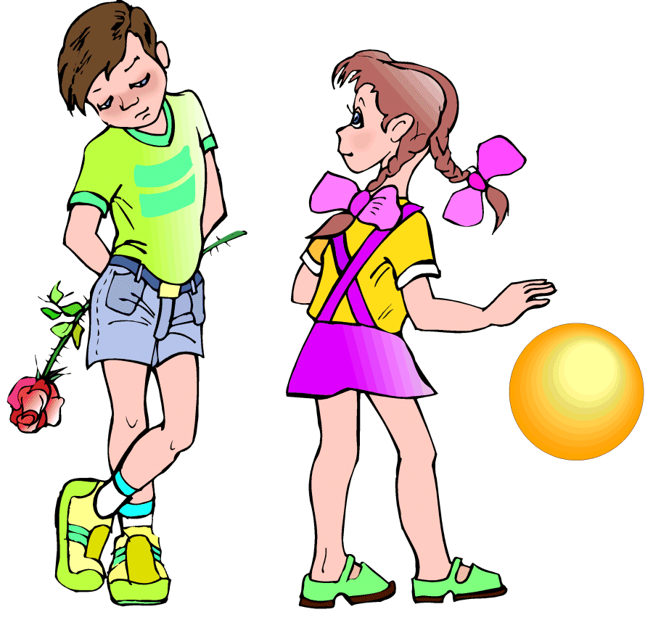

6. There are three kids in the picture.

7. The girl is playing with a yellow ball.

8. The boy is looking at the girl.

10. The kids are wearing sneakers.

9. The boy is hiding a red rose.

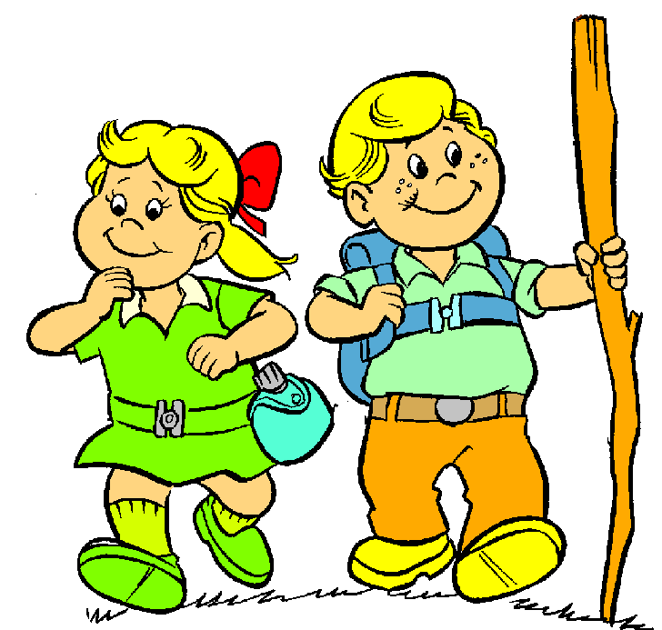

12. The kids look tired.

11. Two kids are out hiking.

14. The girl is carrying a backpack.

13. The boy is holding on to a stick.

16. The boy is wearing a green belt.

15. They are both looking at each other.