T / F 1. Duncan shows his bookcase.

T / F 2. There are no books on the middle shelf.

T / F 3. He uses his left hand to point at the books.

Circle the correct answer:

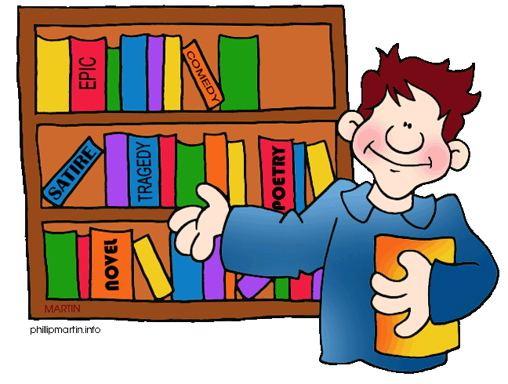1.

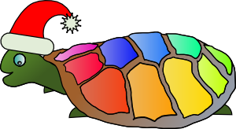2.

T / F 1. Here you see a green turtle with a cowboy hat.

T / F 2. The turtle has a rainbow coloured shell.

T / F 3. The shell has eleven different colours.

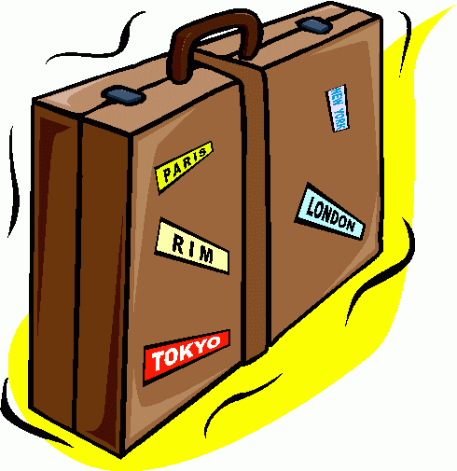3.

T / F 1. In the picture is a small black suitcase.

T / F 2. There are five stickers on the suitcase.

T / F 3. The handle is brown.

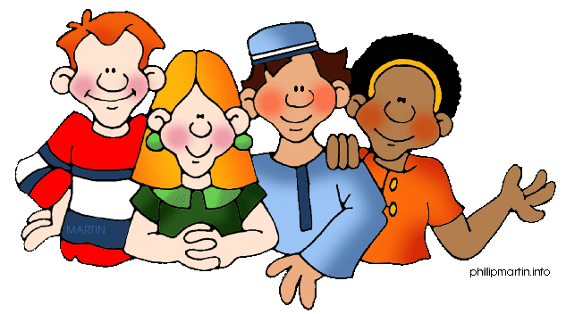

T / F 1. You see three people.

T / F 2. They all wear striped T-shirts

T / F 3. No one wears a hat.

4.

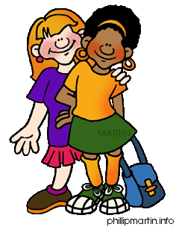5.

T / F 1. The dark-haired girl is taller than the light-haired girl.

T / F 2. They both wear ear rings.

T / F 3. One wears a skirt and the other blue jeans.

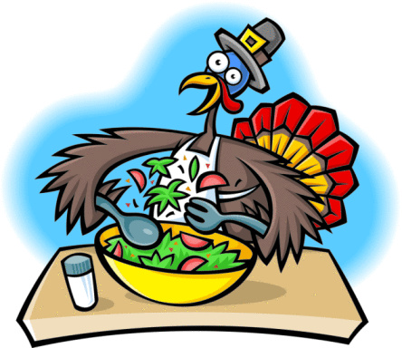6.

T / F 1. A duck is busy mixing a salad in the kitchen.

T / F 2. There are lettuce, tomatoes, and carrots in the salad.

T / F 3. In front of the salad is a glass of milk.

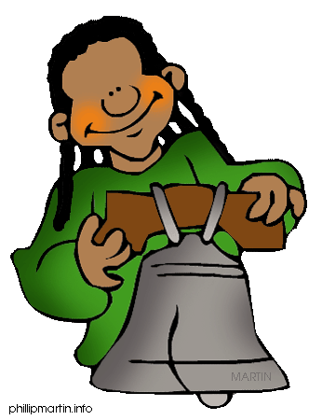7.

T / F 1. The girl is behind a bell.

T / F 2. The bell is grey and big.

T / F 3. The girl has a pony tail.

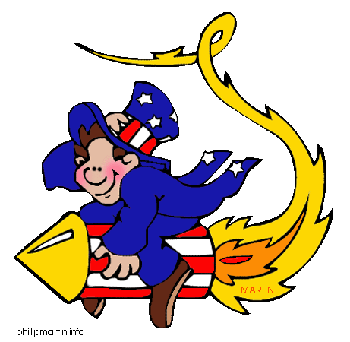

8.

T / F 1. The guy is flying on a rocket.

T / F 2. He holds on to his hat.

T / F 3. The clothes show that the guy is from England.

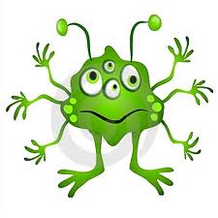

9.

T / F 1. The monster has 8 hands.

T / F 2. Each hand has 5 fingers.

T / F 3. The monster has g0t two legs with two feet.

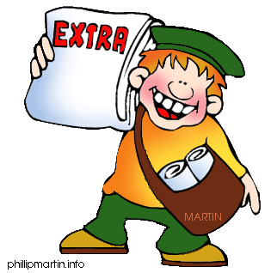

T / F 1. The boy sells newspapers.

T / F 2. The boy is smiling.

T / F 3. The papers are in the brow sling bag.

10.