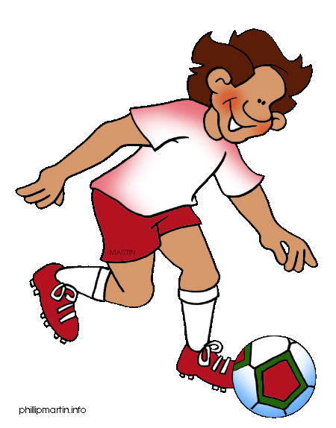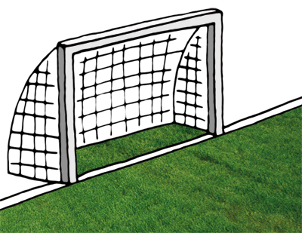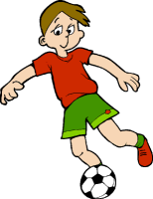

1. Eleven players!

2. Someone who directs the training and performance of a sports team.

3. Someone who trains a soccer team.

4. A loose shirt worn by a player.

5. Soccer “shoes”.

6. To try to get the ball from an opposing player.

7. The best player of a match.

8. A kick in soccer that a player makes when the other team has a rule.

9. Three goals scored by one player in a game.

10. Colour of card shown when you are not allowed to play any longer in a game.

11. An action that is against the rules.

12. The opposite of home team.

13. An area that is used for playing sports.

14. The man wearing black.

15. A shot made by hitting the ball with your head.

16. To stop from scoring a goal.

17. Not *onside*.

18. The clothing of a team.