Scorecard
Scorecard
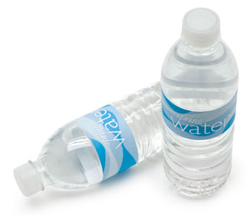
Scorecard
Scorecard
Scorecard
Scorecard
Spin the Bottle
The old, wellknown Spin the Bottle is good to use when working with beginners and new vocabulary. Make some flashcards of vocabulary that you want to teach (nouns, alphabet, numbers etc.) and place them in a circle. Put a water bottle in the middle and have a student spin the bottle. When it points to a flashcard, the student must say and pronounce the word correctly to earn a in one of the spaces. If the student doesn’t know the word or can’t pronounce it correctly, the student receives a . Who earns most ?
-Make photocopies of the scorecards and cut them out. Hand one to each student.

