FILL IN THE BLANKS WITH SUBJECTS PRONOUNS
  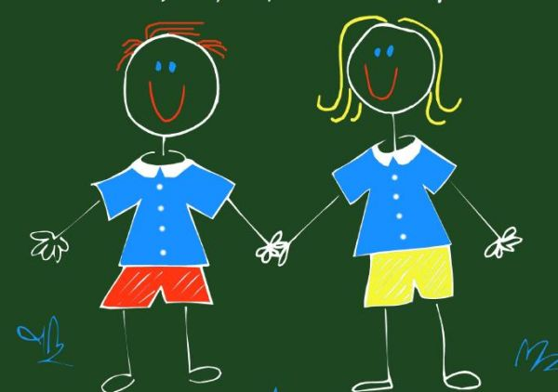  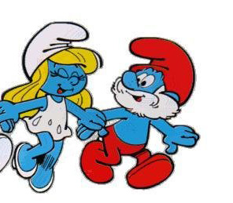  SHE  is Şirine.  HE  is Şirin Baba.  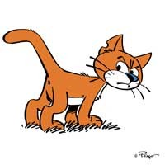  IT  is Azman.  WE  are Şirinler.  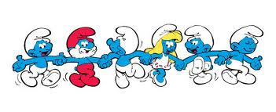  THEY  are Şirinler’s houses.  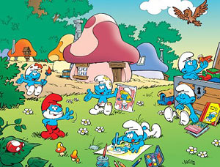 | I  am Gargamel.  YOU  are students.  SHE  is Şirine.  HE  is Şirin Baba.  IT  is Azman.  WE  are Şirinler.  THEY  are Şirinler’s houses.
I
am Gargamel.
YOU
are students.

( I - YOU – HE – SHE – IT – WE – THEY )

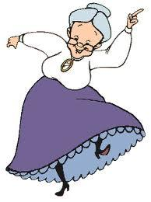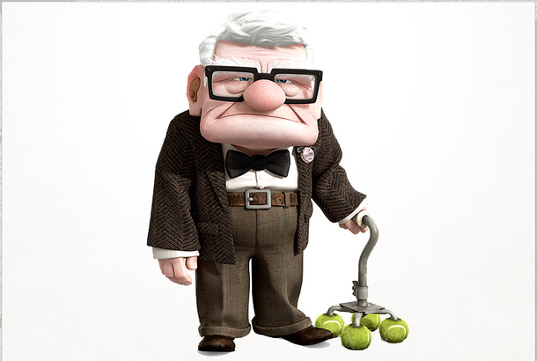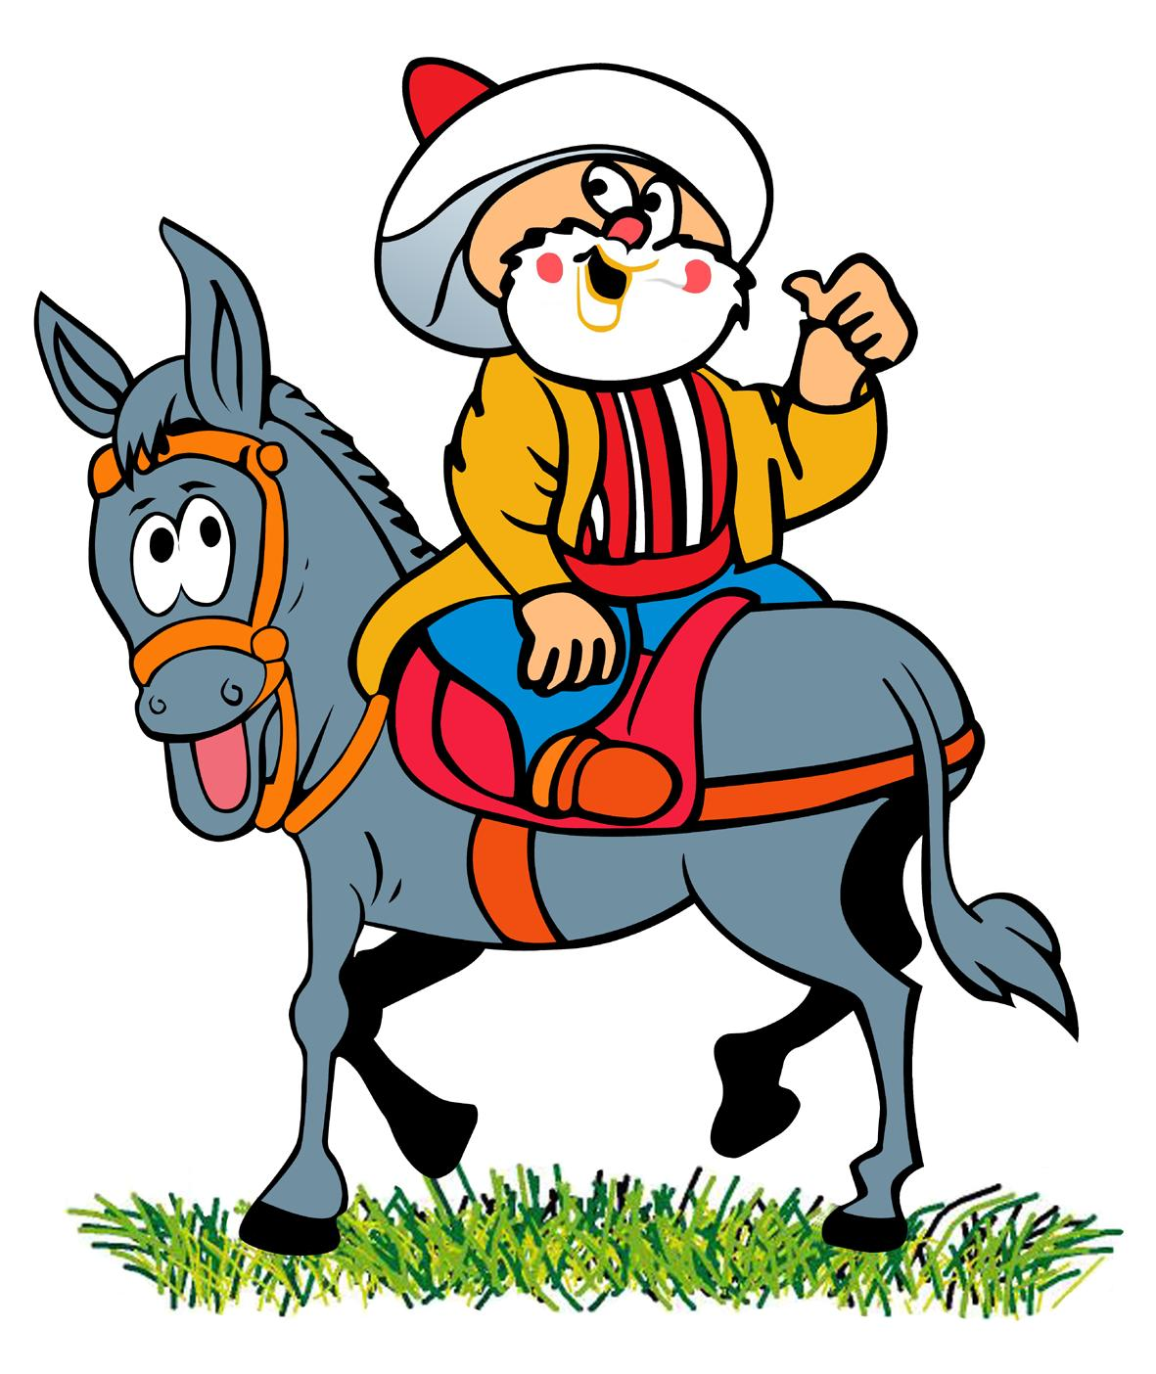

1)………….is a cat. 2)………..is an old woman. 3)…………….is an old man. 4)………am Nasreddin Hodja.

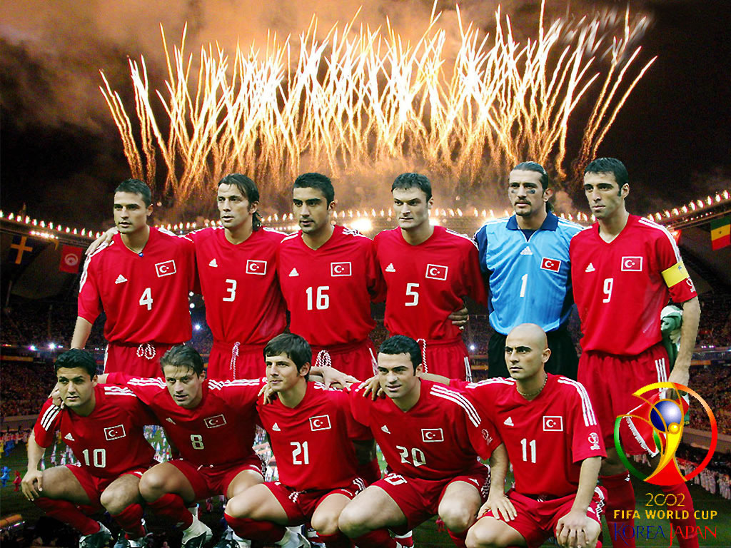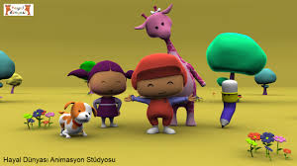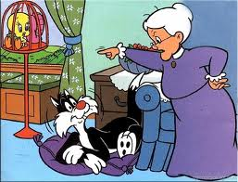

4)………are foatballers. 5)………..are cartoon characters. 6)…….are Tweety and Slyvester.

