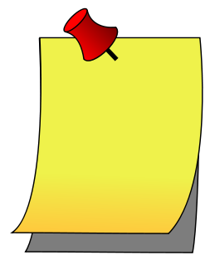

Choose the right option (than/then):

1. I have learnt more this year __________ the previous year.

2. My friend is way smarter ___________ you think.

3. ___________ things happened fast.

4. If you go first ___________ I will follow.

5. First you read the recipe, ____________ you start making the cookies.

6. He does other stuff _________ football.

7. It is more important _________ you think!

8. I wasn’t ready ___________.

9. I went to my mum’s ___________ to my dad’s.

10. He told me to do it, __________ he left without saying more.

11. It is $1,995.00 and ___________ there’s tax too.

12. Were you ready _________?

13. I would rather go by bike ________ by car.

14. I will see you _________.

15. He has lived here longer __________ I have.

16. His hair is very different _________ mine.

17. Let’s go to the store __________ come back home and have a cup of tea.

18. I believe Los Angeles is bigger ________ New York.

19. You should first do your chores _________ you can spend time on pleasure activities.

20. First one thing ________ the other.

21. Why don’t you call your dad first! ________ we can make up our minds.

Is used as a time marker or in with a sequence of events

Is used in comparative statements