**Transport & Travelling: Vocabulary Quiz!!**

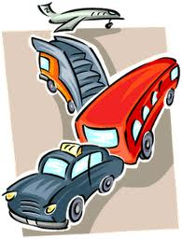

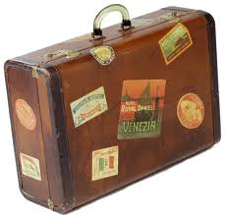

A person whose job is to serve and take care of passengers on an aircraft:

A comfortable bus for carrying passengers over long distances:

A place where taxis park while they are waiting for passengers:

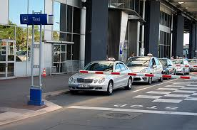

a. taxi ring

b. taxi lane

c. taxi rank

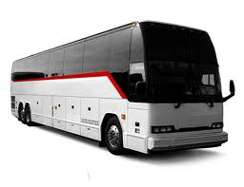

a. couch

b. carriage

c. coach

a. flight assistant

b. flight attendant

c. flight sergeant

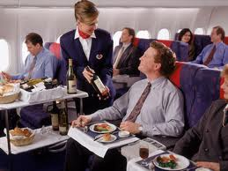

A sum of money that must be paid as punishment for parking illegally:

A small vehicle at the airport that can be pushed and is used for carrying the luggage:

A person walking in the street and not travelling in a vehicle:

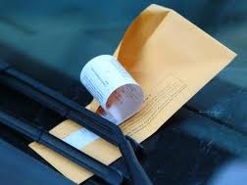

a. parking bill

b. parking fine

c. parking receipt

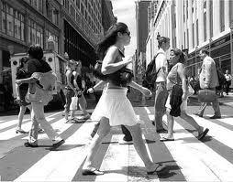

a. pedestrian

b. pedometer

c. pedant

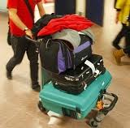

a. pedalo

b. trolley

c. pram

A stamp or mark put in your passport by officials of a foreign country, which permits you to enter their country:

A place where roads meet, forming a circle that all traffic must go around in the same direction:

A hat made of very strong material worn when riding a motorcycle to protect your head:

a. vice

b. visa

c. vista

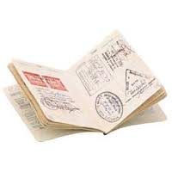

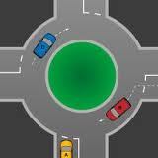

a. merry-go-round

b. roundabout

c. rounders

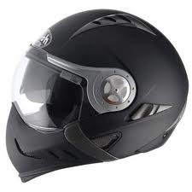

a. armour

b. helmet

c. beaver hat

A vehicle driven by electricity that runs on rails along the streets and carries passengers:

The flat area at a train station where you get on or off the train:

The part of a train where you can buy something to eat and drink:

a. canteen car

b. buffet car

c. gorging car

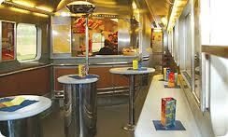

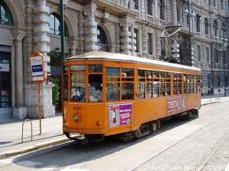

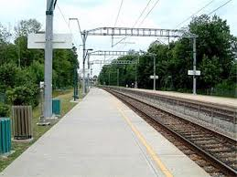

a. runway

b. platform

c. deck

a. tramp

b. tram

c. trap

The passage between rows of seats in a plane:

A part of a road that only bicycles are allowed to use:

A long line of vehicles on a road that cannot move or can only move very slowly:

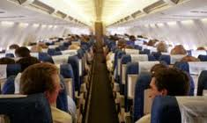

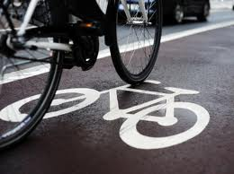

a. cycle path

b. cycle line

c. cycle lane

a. corridor

b. island

c. aisle

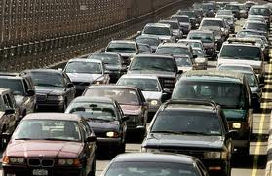

a. traffic marmalade

b. traffic soup

c. traffic jam

A vehicle, usually smaller than a lorry, used for carrying goods or people:

arrying goods or people:

A kind of machine used to fill in the bicycle tyres with air:

A journey by sea, visiting different places, especially as a holiday:

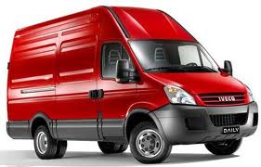

a. van

b. truck

c. trunk

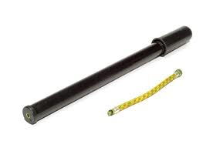

a. bicycle filler

b. bicycle pump

c. bicycle saddle

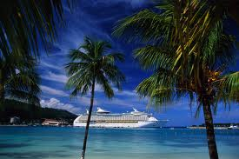

a. crusade

b. cruise

c. cruiser

What’s the name of the jacket without sleeves, that can be filled with air designed to help you float if you fall in water?

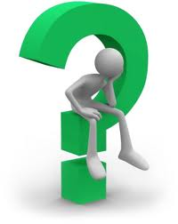

What’s the name of the safety device in a car that fills with air if there is an accident, to protect the people in the car?



How do you call the area of road marked with broad black and white lines where vehicles must stop for people to walk across?







How do you call the small hole in a bicycle or car tyre, made by a sharp point?

What’s the verb which means “to go past a moving vehicle ahead of you because you are going faster than they are”?



How do you call the time, usually twice a day, when the roads are full of traffic because people are travelling to or from work?





What’s the name of the space at the back of a car where you put bags, cases, etc., in?

How do you call the small room on a ship in which you live or sleep?



What’s the verb which means “to leave the ground and begin to fly” (of e.g. an airplane)?

__________________________________________________________________________________________________________

**ANSWERS**

1. A person whose job is to serve and take care of passengers on an aircraft: **FLIGHT ATTENDANT**
2. A comfortable bus for carrying passengers over long distances: **COACH**
3. A place where taxis park while they are waiting for passengers: **TAXI RANK**
4. A small vehicle at the airport that can be pushed and is used for carrying the luggage: **TROLLEY**
5. A person walking in the street and not travelling in a vehicle: **PEDESTRIAN**
6. A sum of money that must be paid as punishment for parking illegally: **PARKING FINE**
7. A hat made of very strong material worn when riding a motorcycle to protect your head: **HELMET**
8. A place where roads meet, forming a circle that all traffic must go around in the same direction: **ROUNDABOUT**
9. A stamp or mark put in your passport by officials of a foreign country, which permits you to enter their country: **VISA**
10. The flat area at a train station where you get on or off the train: **PLATFORM**
11. A vehicle driven by electricity that runs on rails along the streets and carries passengers: **TRAM**
12. The part of a train where you can buy something to eat and drink: **BUFFET CAR**
13. A part of a road that only bicycles are allowed to use: **BICYCLE LANE**
14. A long line of vehicles on a road that cannot move or can only move very slowly: **TRAFFIC JAM**
15. The passage between rows of seats in a plane: **AISLE**
16. A journey by sea, visiting different places, especially as a holiday: **CRUISE**
17. A kind of machine used to fill in the bicycle tyres with air: **BICYCLE PUMP**
18. A vehicle, usually smaller than a lorry, used for carrying goods or people: **VAN**
19. What’s the name of the safety device in a car that fills with air if there is an accident, to protect the people in the car?: **AIRBAG**
20. How do you call the area of road marked with broad black and white lines where vehicles must stop for people to walk across?: **ZEBRA CROSSING**
21. What’s the name of the jacket without sleeves, that can be filled with air designed to help you float if you fall in water?: **LIFE JACKET**
22. How do you call the time, usually twice a day, when the roads are full of traffic because people are travelling to or from work?: **RUSH HOUR**
23. What’s the verb which means “to go past a moving vehicle ahead of you because you are going faster than they are”?: **OVERTAKE**
24. How do you call the small hole in a bicycle or car tyre, made by a sharp point?: **PUNCTURE**
25. What’s the name of the space at the back of a car where you put bags, cases, etc., in?: **BOOT**
26. What’s the verb which means “to leave the ground and begin to fly” (of e.g. an airplane)?: **TAKE OFF**
27. How do you call the small room on a ship in which you live or sleep?: **CABIN**