**2. BODY SCRIPT LIGHT**

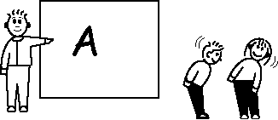

**SUMMARY**

Writing letters in the air with a finger can get tedious. It's more fun to write with a bottom, a head, a stomach, or even a friend's finger.

**SET–UP**

 Write the letters of the alphabet on the board. Ask the class to stand up in front of you.

**PLAY**

Choose a letter to practice writing. Trace the letter in the air with your finger. Ask the students to repeat with their own fingers. Now choose another body part to trace the letter in the air with. Don't worry if the students can't make a perfect A with their heads. This part of the activity is just to break the monotony.

Repeat the above steps with other letters.

**USES**

1. For fun.