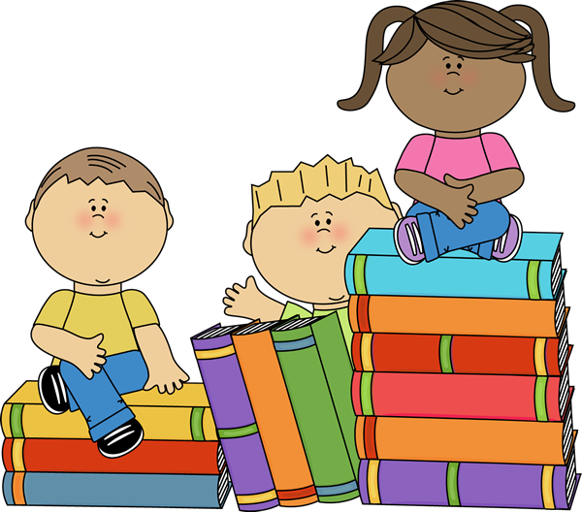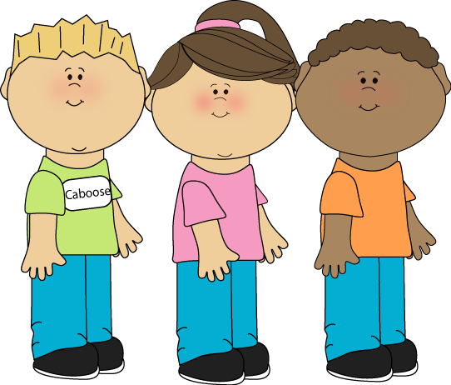

**What is your favourite time for reading?**

**How do you choose the books you are going to read?**

**Most people say the book is better than the movie. Is this true for you?**

**Do you watch the movie that came from a book?**

**Do you read books based on recommendations?**

**How many books have you read in your life?**

**What is your favourite story?**

**And who is your favourite author?**

**What is the longest book you have ever read? How long did it take to read it?**

**Instructions:**

**1. Cut the cards out and laminate them if you want them to last longer.**

**2. Pair students in twos.**

**3. Give them some cards and have them walk from one point to another. One leg = one card.**