________________________________________________________________________________________________________________________________________________________________________________________________________________________________________________________________________________________________________________________________________________________________________________________________________________________________________________________________________________________________________________________
________________________________________________________________________________________________________________________________________________________________________________________________________________________________________________________________________________________________________________________________________________________________________________________________________________________________________________________________________________________________________________________

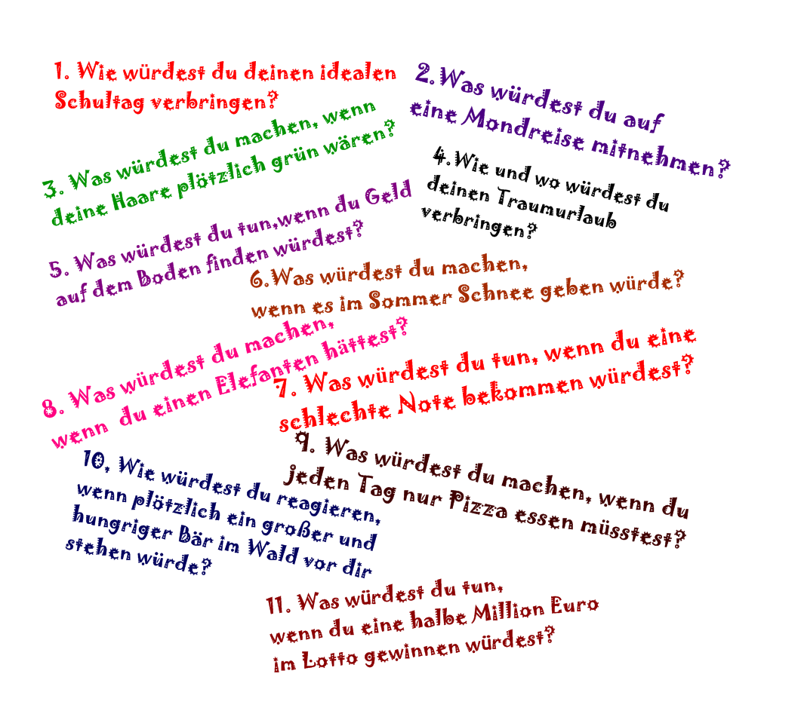

Template ist von Philip Roeland.

