WELCOME TO ENGLISH

**1) Write the correct word under the pictures**

**evening – night – afternoon – morning**



**1.** _______________ **2.** ________________ **3.** ______________ **4.** ______________

**2) Find the correct greeting in the spiral and write it under the pictures.**

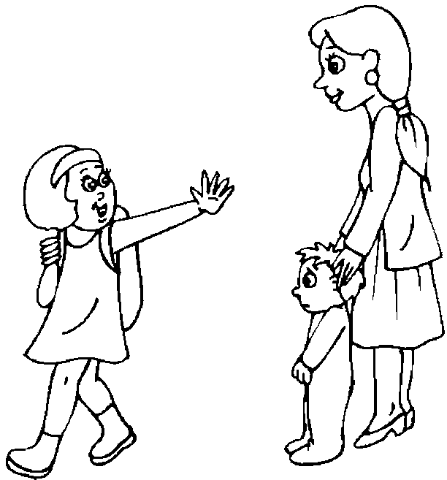  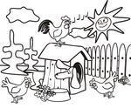 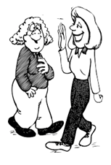

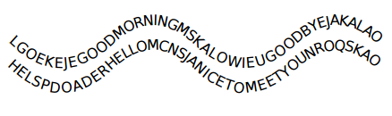

**3) Find the correct answer for the questions.**

|  |  |  |
| --- | --- | --- |
| 1. What’s your first name? | a. I’m fine. |  |
| 2. What’s your last name? | b. In October |  |
| 3. How old are you? | c. He is a teacher. |  |
| 4. When is your birthday? | d. Sara. |  |
| 5.What’s that | e. No, I can’t |  |
| 6. What is your favorite color? | f. She is a housewife |  |
| 7. What’s your father’s job? | g. Kabiri |  |
| 8. What’s your mother’s job? | h. I’m thirteen. |  |
| 9. Can you play tennis? | i. It’s an elephant |  |
| 10. How are you? | j. Green. |  |