**Simple Plan** is a [French-Canadian](http://en.wikipedia.org/wiki/French-Canadian) [rock](http://en.wikipedia.org/wiki/Rock_music) band from [Montréal, Québec](http://en.wikipedia.org/wiki/Montr%C3%A9al,_Qu%C3%A9bec). The band has had no lineup changes since its inception in 1999. They have released four studio albums: [*No Pads, No Helmets...Just Balls*](http://en.wikipedia.org/wiki/No_Pads,_No_Helmets...Just_Balls) (2002), [*Still Not Getting Any...*](http://en.wikipedia.org/wiki/Still_Not_Getting_Any...) (2004), [*Simple Plan*](http://en.wikipedia.org/wiki/Simple_Plan_(album)) (2008) and [*Get Your Heart On !*](http://en.wikipedia.org/wiki/Get_Your_Heart_On!) (2011); as well as two widely marketed [live albums](http://en.wikipedia.org/wiki/Live_album): [*Live in Japan 2002*](http://en.wikipedia.org/wiki/Live_in_Japan_2002) (2003) and [*MTV Hard Rock Live*](http://en.wikipedia.org/wiki/MTV_Hard_Rock_Live) (2005).

They performed at the [Vans Warped Tour](http://en.wikipedia.org/wiki/Vans_Warped_Tour) every year from 1999-2005 and in 2011.

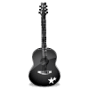







🗹 **ACTIVITY 1 : REORDER THE SENTENCES…**

🗹 **ACTIVITY 3 : MATCH BOTH COLUMNS…**

Do you wanna everyone around ?  
Are you sick of smiles and stupid lies   
Are you desperate a world you hate ?   
Before your feeling so left out ?  
Are you stuck inside you're bleeding   
Are you sick of to find something more ?  
With their big fake life is over   
While deep inside be somebody else ?

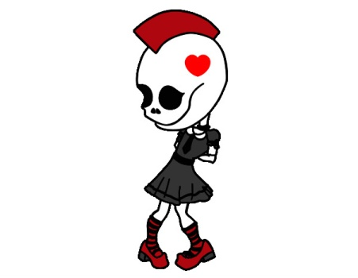Do you ever feel like breaking down ?  
That no one hears you screaming  
Do you ever wanna run away ?   
Like somehow you just don't belong  
And no one understands you  
Do you ever feel out of place ?   
With the radio on turned up so loud  
Do you lock yourself in your room ?

**Chorus :**

🗹 **ACTIVITY 2 : FIND THE MISSING WORDS…**

*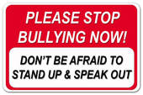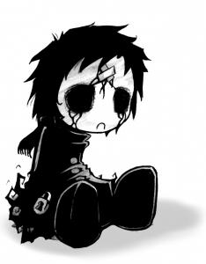No you don’t know what it’s __ __ __ __  
When nothing feels __ __ __ __ __ __ __  
You don’t know what it’s __ __ __ __  
To be like __ __*  
*To be __ __ __ __  
To feel __ __ __ __  
To be __ __ __ __ out in the dark  
To be __ __ __ __ __ __ when you're down  
To feel like you've been __ __ __ __ __ __ around  
To be on the edge of __ __ __ __ __ __ __ __ down  
And no one's there to __ __ __ __ you  
No, you don't know what it's __ __ __ __***Welcome to my life**

🗹 **ACTIVITY 4 : CIRCLE THE CORRECT WORD…**

No one ever **lied / tied** straight to your face  
No one ever **stabs / grabs** you in the back  
You might think I'm **silly / happy**  
But I'm not **wanna / gonna** be ok /   
Everybody always **made / gave** you what you wanted  
You never **sad / had** to work  
It **was / wash** always there  
You don't **show / know** what it's like  
What it's like

**Welcome to my life**

**ACTIVITY 4 : CHOOSE THE CORRECT WORD**

No one ever **lied / tied** straight to your face  
And no one ever **grabbed / stabbed** you in the back  
You might think I'm **silly / happy** but I'm not gonna be okay  
Everybody always **made / gave** you what you wanted  
You never had to **work / wash** it was always there  
You don't **know / show** what it's like, what it's like  
***Welcome to my life***

 🗹 **ACTIVITY 5 : Look at the lyrics : classify them into the grid below :** 🗹 **ACTIVITY 6 : Find the English words / expressions for :**

**1. *fondre en larmes* __________________________**

**2. *ne pas être à sa place* __________________________**

**3. *être au bord du…* __________________________**

**4. *être mis à l’écart* __________________________**

**5. *être coincé* __________________________**

**6. *bien en face* __________________________**

**7. *poignarder dans le dos*** __________________________

***3.Victim’s reactions***

***2.Victim’s feelings***

***1.Acts of bullying***

