Comment the situations, using immediate Future. Match the sentences with the pictures.

- John is at the club. It’s a beautiful sunny day. ______________________________________________________________________
- Bruno is at the Shopping Center. Tomorrow is his girl’s birthday. ______________________________________________________________________
- Angela and Rachel are hungry. It’s 1:00 o’clock in the afternoon. ______________________________________________________________________
- Mary and Paul are at the cinema. ______________________________________________________________________
- Rebecca is waiting for a bus. ______________________________________________________________________
- Peter’s girl doesn’t live in the same town. He misses her so much. ______________________________________________________________________
- Charles has a difficult Math's test on Wednesday. ______________________________________________________________________
- Angela and Lena don’t want to go to school on foot. _____________________________________________________________________
- Linda and Tim are thirsty. _____________________________________________________________________
- Joe likes the winter. ______________________________________________________________________

1 share a coke – 2 have lunch – 3 ski – 4 buy a present – 5 see a movie
6 go to work – 7 visit her – 8 study a lot – 9 take the subway – 10 play tennis

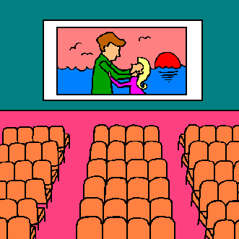 |  |  |  | 
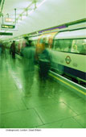 |  |  |  | 

