1

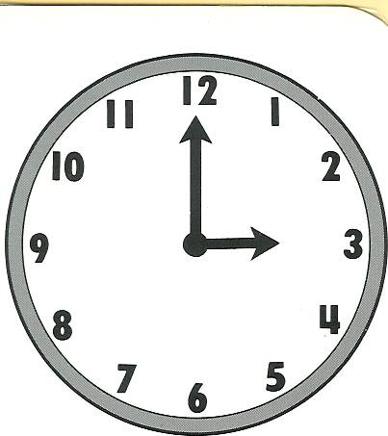

2

You are in a hurry. Run to ten past eight.

3

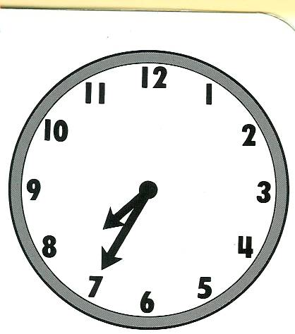

4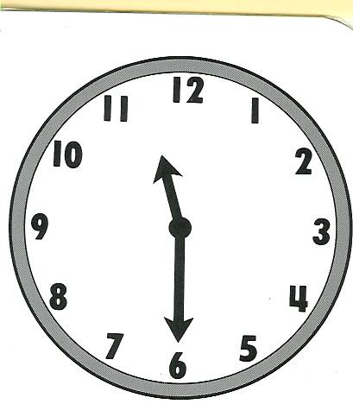

5

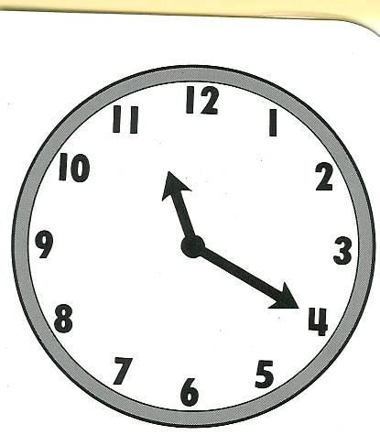

6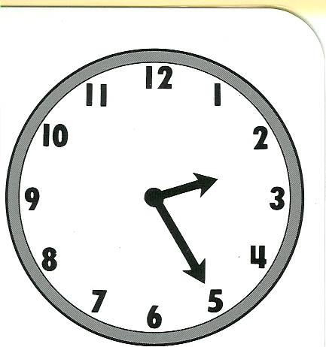

7

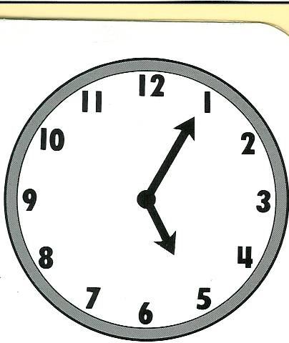

8

Waint for a friend.

9

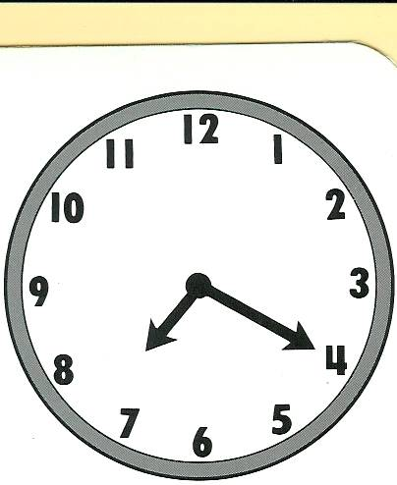

10

Go back to three o’clock.

11

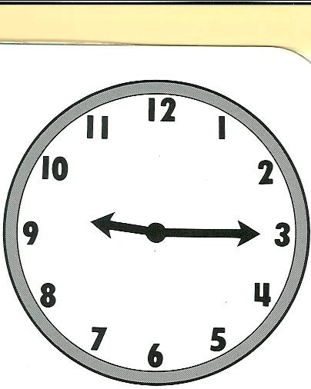

12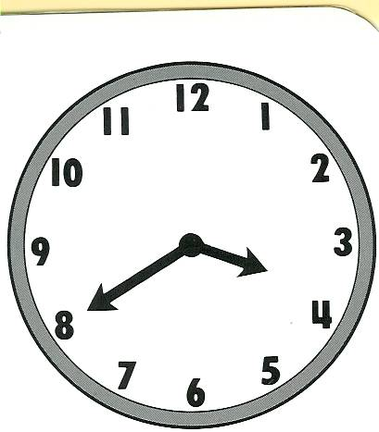

13

Miss a turn.

14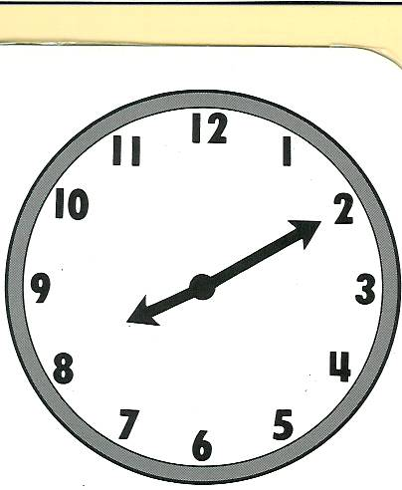

15

You are early for your meeting. Go back to twenty to eight.

16

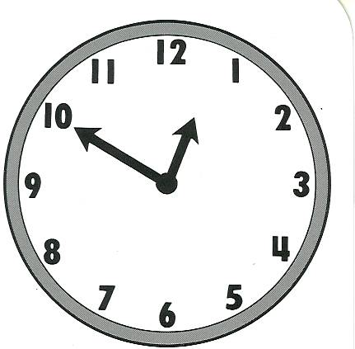

17

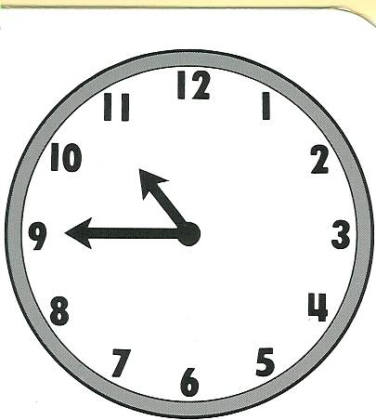

18

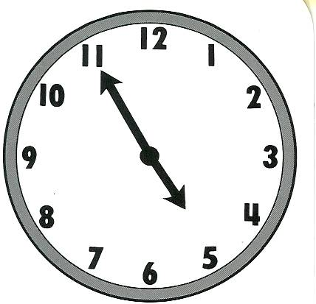

19

You are going to meet a friend at ten to one.

20

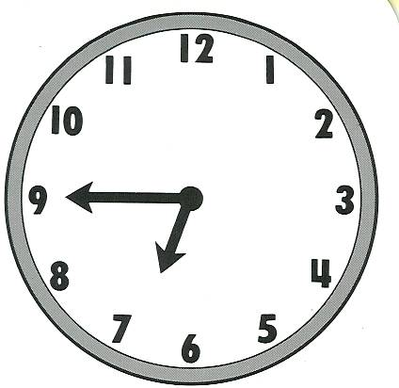

21

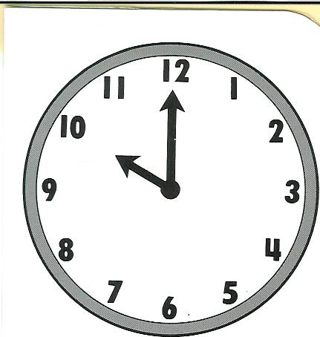

22

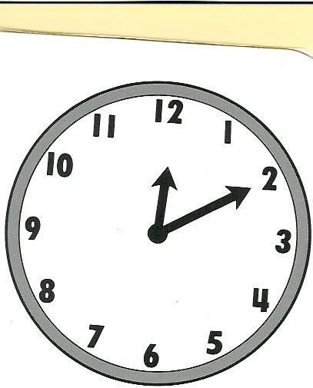

23

Return to five to five.

24

Dinner is served. Miss a turn.

25

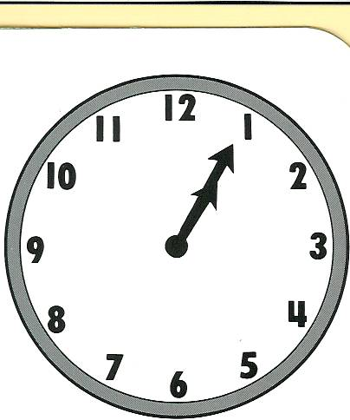

26

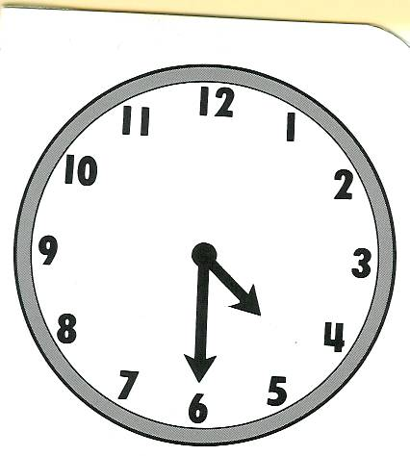

27

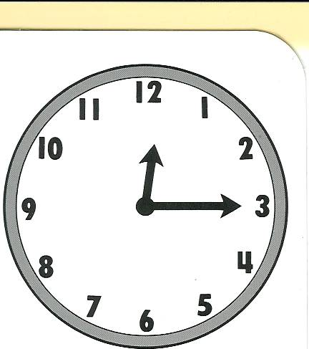

28

Wait for a friend.

29

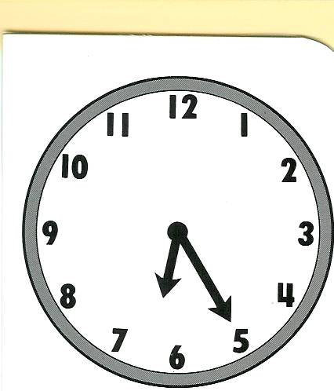

30

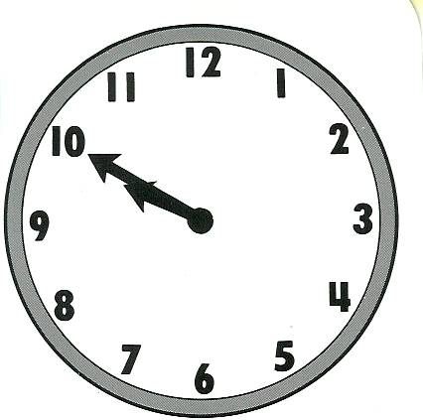

FINISHED

1

It is three o’ clock.

2

You are in a hurry. Run to ten past eight.

3

It is twenty to eight.

4

It is half past eleven.

5

It is twenty past eleven

6

It is twenty past two.

7

It is five past five.

8

Wait for a friend.

9

It is twenty past seven.

10

Go back to three o’clock.

11

It is quater past nine.

12

It is twenty to four.

13

Miss a turn.

14

It is ten past eight.

15

You are early for your meeting. Go back to twenty to eight.

16

It is ten to one.

17

It is quater to eleven.

18

It is five to five

19

You are going to meet a friend at ten to one.

20

It is quater to seven.

21

It is ten o’ clock.

22

It is ten past noon (midnight).

23

Return to five to five.

24

Dinner is served. Miss a turn.

25

It is five past one.

26

It is half past four.

27

It is quater past twelve.

28

Wait for a friend.

29

It is twenty past six.

30

It is ten to ten.

FINISHED

**Intructions for the teacher.**

**Preparation**

* Print the board games on tick paper or a cardboard; laminate them if you want to use them many times.
* Find tokens for each student.
* Provide dice.
* Divide the class into groups of 3 – 4 students each.
* Give each group a board game and a die.
* Give each student a token (or bean, coin, button, etc.).

**The game**

* The players put their tokens on the square Number 1.
* The first student throws the die and moves his token ahead the corresponding number of squares.
* The student tells the time according to the picture or follows the instruction and goes to the mentioned word.. Advanced students could make a sentence saying what they do at the given time.
* **Example: It is three o’ clock. At three o’ clock I do my homework.**
* If the answer is correct, the student stays, if the answer is incorrect, he has to go back where he came from.
* The first student who takes a number that places his token on “home” or surpasses it is the winner.