


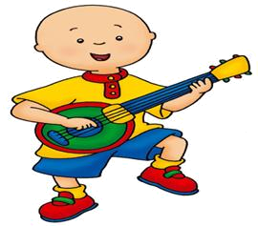
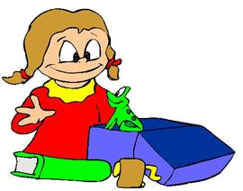
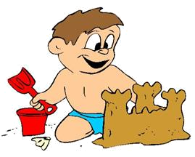









I’m Tim and I’ll be an architect.
I’m Beth, I’ll be a pediatrician.
I’m Helen and I’ll be a nurse.
I’m Nick, I’ll be a journalist.
I’m Ray and I’ll be a singer.
I’m Rachel; I’ll be a vet.
I’m Laura, I’ll be a dancer.
I’m Sylvie; I’ll be an athlete.
I’m Lena; I’ll be a painter.
I’m Cindy; I’ll be a writer.
I’m Bill; I’ll be an auto mechanic.
I’m Zach; I’ll be a police officer.
I’m Paul; I’ll be a teacher.
I’m Ginger, I’ll be a dentist.
I’m Ann and I’ll be a model.
What will you be when you grow up?



Answer the question, as in the models:
What will Ginger be? – She will be a dentist.
What does Ann want to be? – She wants to be a model.
What does Nick want to be?
_____________________________________________________________
What will Beth be?
_____________________________________________________________
What does Helen want to be?
_____________________________________________________________
What does Bill want to be?
_____________________________________________________________
What will Paul be?
_____________________________________________________________
What will Zach be?
_____________________________________________________________
What does Tim want to be?
_____________________________________________________________
What does Cindy want to be?
_____________________________________________________________
What will Laura be?
_____________________________________________________________
What will Rachel be?
_____________________________________________________________
Mark T (true) or F (false) and explain when it’s false:
A. Laura wants to be a singer. ( )
_________________________________________________________________
B. Zack wants to be a police officer. ( )
_________________________________________________________________
C. Nick wants to be a journalist. ( )
_________________________________________________________________
D. Ray wants to be a dancer. ( )
_________________________________________________________________
E. Helen wants to be a doctor. ( )
_________________________________________________________________
F. Bill wants to be a dentist. ( )
_________________________________________________________________
G. Tim wants to be an architect. ( )
_________________________________________________________________

