Put the words in the right places:

caravan walking boots hiker towel music shop hot-air balloon campsite escalator blackboard electronics doctor ambulance shade flippers goggles stingray toilet basin shower computer sunscreen mirror protractor textbook patient needle crutches seaweed computer shop department store

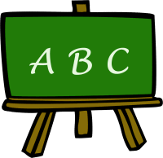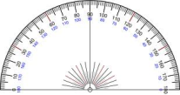

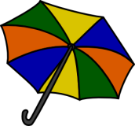

**Beach**

**Mall**

**Bathroom**

**In the country**

**School**

**Hospital**