Which animal is it?

Read the texts about the animals and find the right numbers.
I`m the fastest animal on the planet. I can run more than 100km/ph. I live in Africa.
I`m the biggest animal on the planet. I swim in the sea.
I live in Africa. I have a very long neck and very thin and long legs. I have many spots.

6

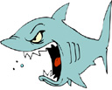
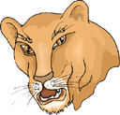
2
133
lion
I live in Africa. I have four legs. I like to relax under trees. People call me the king.of the jungle.
I live in the sea. I eat a lot of meat. People are afraid of me. I have sharp teeth.
shark

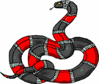
1
blue whale
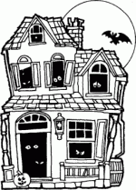
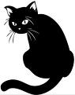
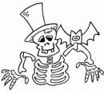
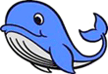
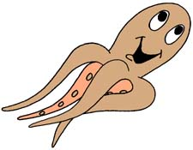
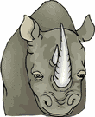
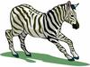
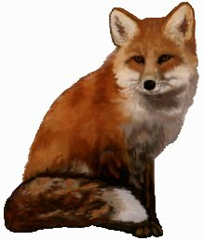
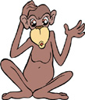
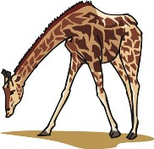
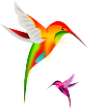
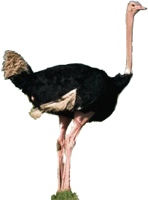
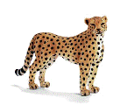
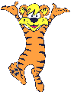
I have four legs. I don`t live in Africa. I`m the biggest cat. I have yellow and black stripes.
I have four legs. I live in Africa. I can run very fast and I have white and black stripes.
I live in Africa. I`m grey and dangerous.I have a bone on my nose.
I live in Africa.
I`m the smallest bird on the planet. I have many colours and live in the rainforest.
I swim in the sea. I have many arms. I use them to swim and to get me some food.
I don`t have legs so I can`t run, but I can swim. I`m very toxic and can kill people.
I live in the trees and like to climb. I really like bananas and coconuts.
8
3
5
4
9
7
12
10
I have four legs and a long tail. My tail has a white spot..

giraffe
zebra
octopus
colibri
fox
tiger
rhino
ostrich
snake
monkey
I live in Africa. I`m the biggest bird on the planet. I can`t fly!!
cheetah
14
11

