21
GO FORWARD 2 SQUARES
23
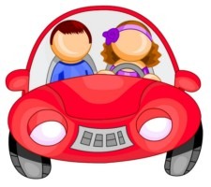

22
8

13
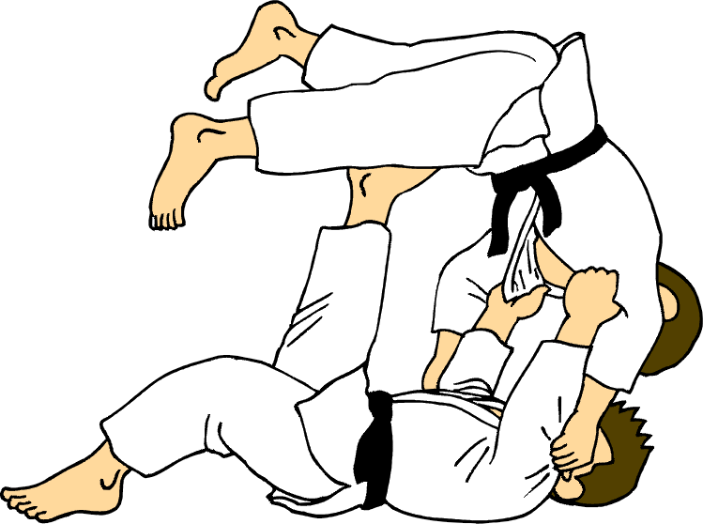

32

MISS A TURN

37

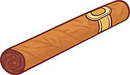

START
1
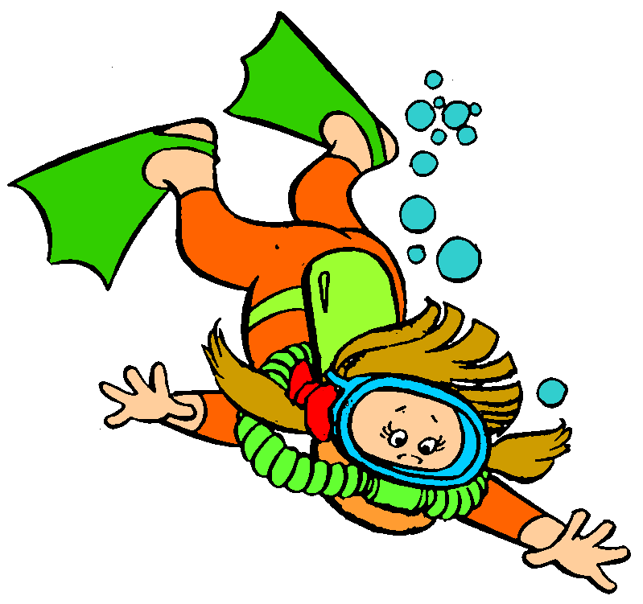

4
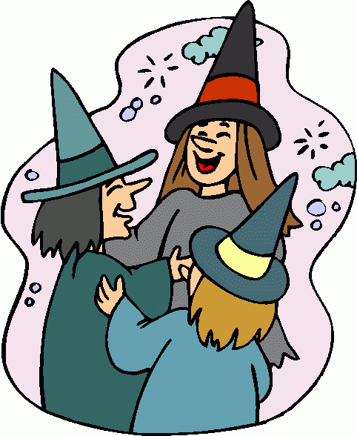
3
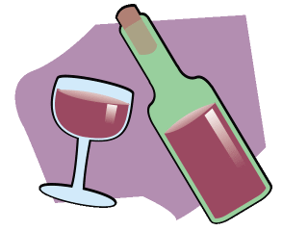
2
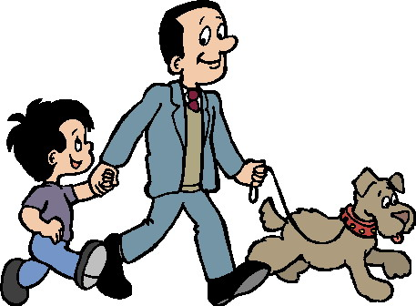

6
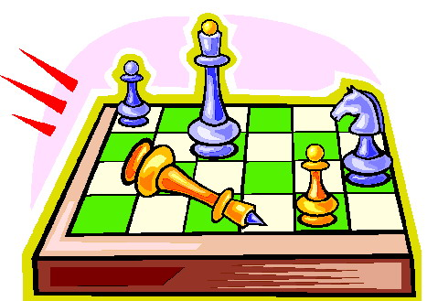
7

MISS A TURN

9
11
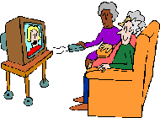
12
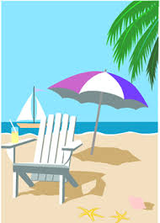
16
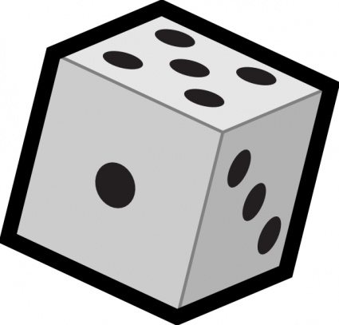

31
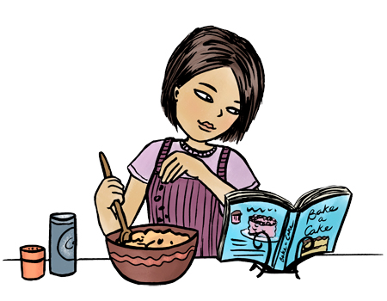
26
27

17
33
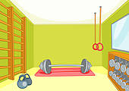

36
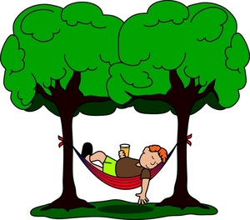

38
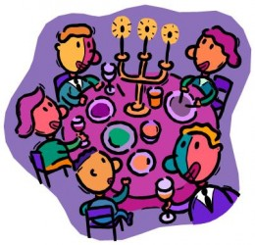
39

41
GO BACK 3 SQUARES

42
43
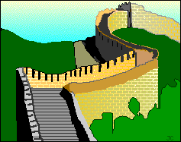

44
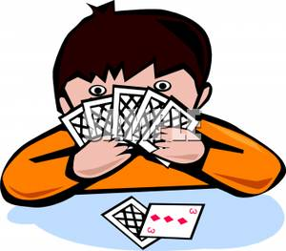
45
5
10
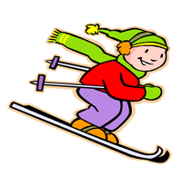

14
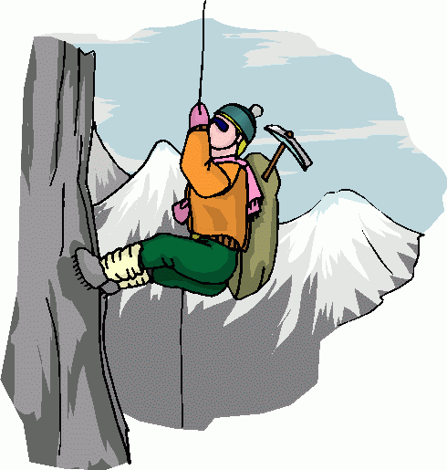
18
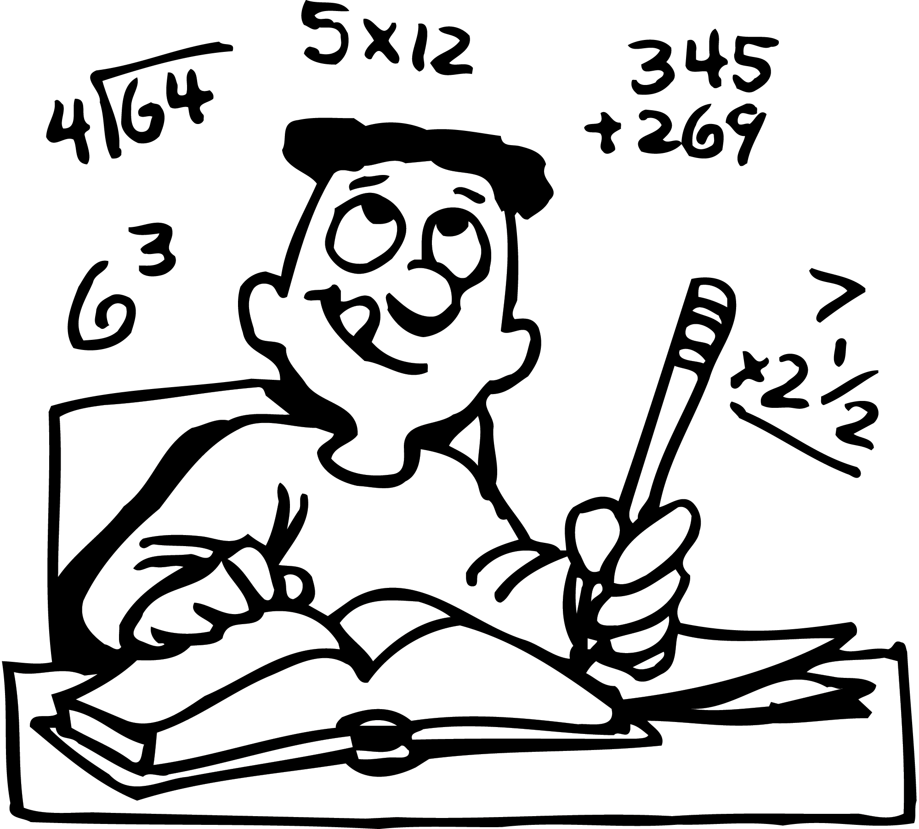
28
34
40
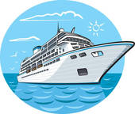

FINISH
15
19
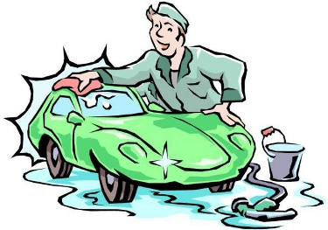
24
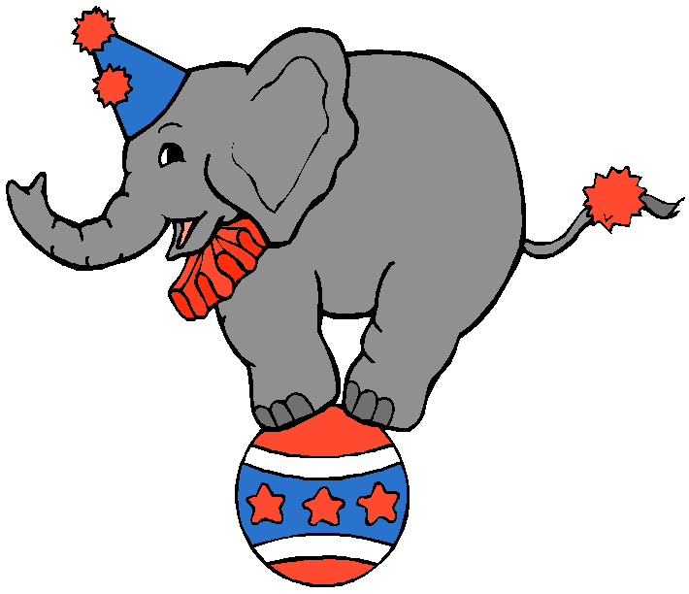
25
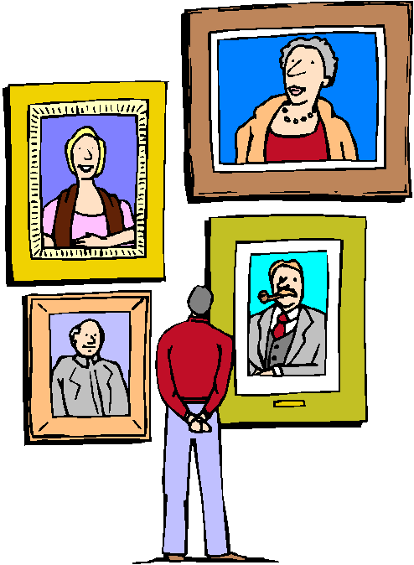
29

GO BACK 3 SQUARES

20
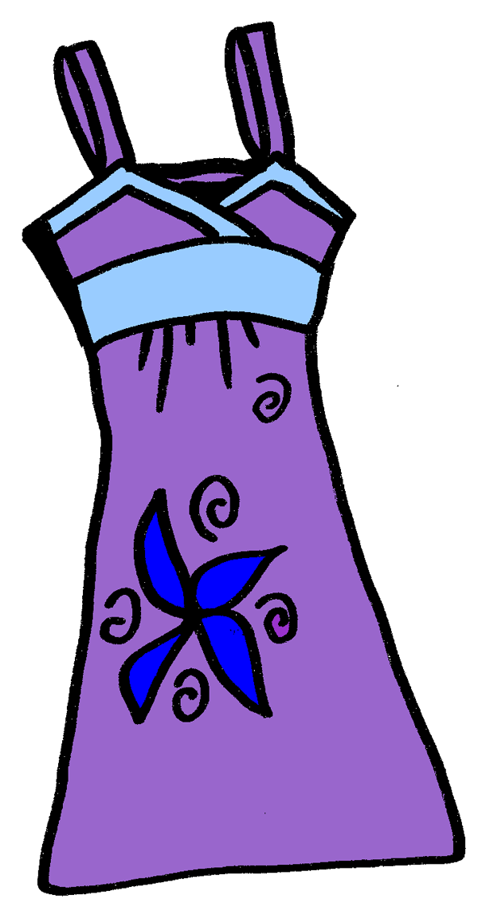

30
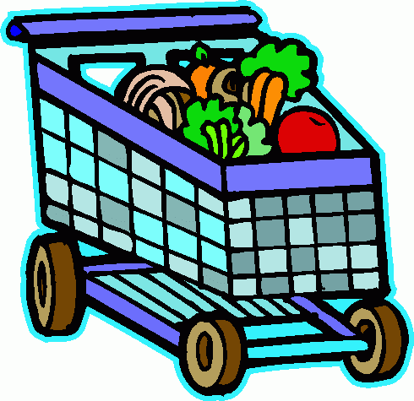

35
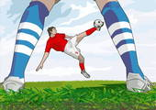
ANSWERS
These are sample sentences. Many others are possible

- Let’s go diving. – Sorry I can’t swim.
- How about walking the dog? - Good idea. It’s a lovely day.
- Would you like a glass of wine? Oh, yes thanks.
- What about organizing a Halloween party? Great idea. I’m using my witch costume.
- ..........
- Let’s play chess. – No, I find chess boring.
- ...........
- What about going to Mc Donald’s. – Oh no, fast food isn’t healthy.
- Would you like to dance? – Yes, I love this song.
- Why don’t we go skiing? – I’m afraid to break my leg.
- Let’s watch TV. – No, there isn’t any good program.
- What about going to the beach? – Yes, I’d like to surf.
- Let’s learn how to fight judo? – Are you crazy, I’m too old for that?
- Let’s go climbing. – Never, it’s too dangerous.
- Would you like to spend the weekend in Rome? – What a nice idea. We can visit the Coliseum.
- ............
- What about buying a new house? – We can’t afford it.
- Let’s study math. – Yes, we have to prepare for the test.
- Let’s wash the car. Oh no, I’ll have it washed tomorrow at the car wash.
- Would you like to buy a new dress? – Yes, let’s go to the mall.
- .......
- Would you like to read the newspaper? – Yes I want to see the movie program.
- Let’s go for a drive. – Sorry, I don’t have a driver’s license.
- Would you like to go to the circus? – No, I don’t. I don’t like that they use animals.
- What about visiting the museum? – That sounds good. I think there is a new exposition.
- .......
- How about playing tennis? – I don’t want, it’s too hot.
- Would you like a cup of tea? – No thanks, I prefer coffee.
- ....
- Let’s go to the supermarket. – Ok. I’m going to buy fruits and vegetables.
- Why don’t you bake a cake? – I’m going to bake a cake on Sunday.
- ........
- Let’s go to the fitness center. – No, I have a personal trainer.
- Would you like to go to a rock concert? – Not really, I hate loud music.
- Why don’t we go to the stadium to watch the soccer game? I’d like to.
- Why don’t you relax in the garden? – I don’t have the time.
- Would you like a cigar? – No thanks, I don’t smoke.
- Let’s have a nice dinner. – That’s a great idea. We can invite our friends.
- ........
- What about a cruise trip in the Caribbean? – I’m afraid I get sea sick.
- ...........
- What about buying a dog? – Oh no, I don’t like pets. They give to much work.
- Why don’t we go to China? - It would be interesting, but it is too far.
- Let’s play cards. – Never, you cheat all the time.
- Why don’t we go parachuting? - Yes, that would be a great adventure.

Instructions for the teacher.

Preparation
- Print the board games on tick paper or a cardboard; laminate them if you want to use them many times.
- Find tokens for each student.
- Provide dice.
- Divide the class into groups of 3 – 4 students each.
- Give each group a board game and a die.
- Give each student a token (or bean, coin, button, etc.).

The game
- The players put their tokens on the first square.
- The first student throws the die and moves his token ahead the corresponding number of squares.
- The student makes a suggestion with one of the expressions from the title according to the picture. The next student has to answer according to the smiley.
- Example: Let’s go diving. – Sorry, I can’t swim.
What about walking the dog? – Good idea, it’s a nice day.
- If the answer is correct, the student stays, if the answer is incorrect, he has to go back where he came from.
- If the student comes to a square with the symbol , he rolls the die again.
- The first student who takes a number that places his token on “FINISH” or surpasses it is the winner.

