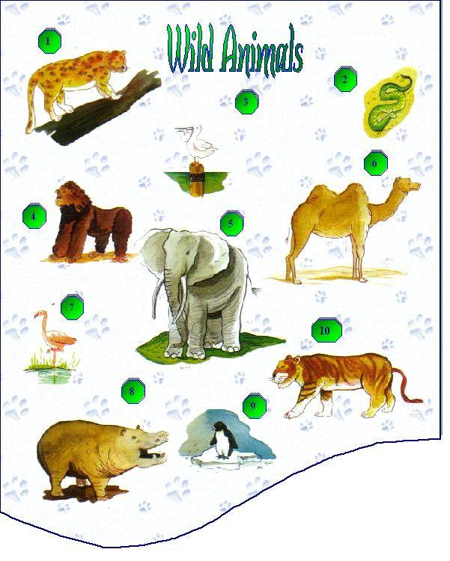
Snake
Leopard
Elephant
Penguin
Gorilla
Beaver
Hippopotamus
Flamingo
Tiger
Camel

1. _________ 2. _________ 3. _________
4. _________ 5. _________ 6. _________
7. _________ 8. _________ 9. _________
10. _________

