
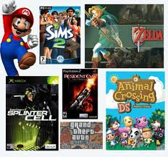
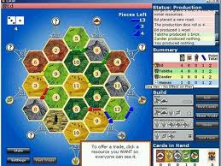
Writing Clinic: Creative Writing Prompts (10)
My favourite computer game
Now it’s time to write. Use the questions above to help you. You can illustrate
your writing with pictures of the game if you want.
PS: Write on every other line so the teacher has some space to correct.

Think about this before you start writing:

- What’s the name of your favourite game?
- What kind of game is it? (Sim, RPG, shoot’em-up, puzzle, strategy,…)
- How often do you play it?
- Is it an online game or do you install it on your computer?
- Where do you play it?
- Why do you like it?
- How do you play it and what do you have to do?
- How good are you at it?
- Is it free or do you have to pay for it?
- Who else plays it?
- Is it a popular game?
- …

