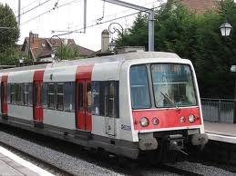
Writing Clinic: Creative Writing Prompts (13)
My City
Now it’s time to write. Use the box above to help you. You can illustrate
your writing with pictures of your city if you want.
PS: Write on every other line so the teacher has some space to correct.

Think about this before you start writing:

- What’s the name of your city? Where is it?
- What is your city like? (e.g. crowded, hot, modern)
- What can you see and do there?
- Are there any tourist attractions?
- How many people live there?
- What kind of jobs do people do?
- How can you get around in your city?
- What is the public transport like?
- What are the people like?
- What do you like about your city?
- Were any famous people born there?
- Would you recommend a visit to your city? Why (not)?

