Name: ____________________________________ Number:______ Class: ____/____
NUMBERS
1. Observe the pictures, understand the words, and then write.
Resimleri inceleyiniz, sözcükleri öğreniniz, ve sonra yazınız.
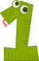 | 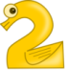 |  |  | 
One  ____________________________________________________________ | Two  ____________________________________________________________ | Three  ____________________________________________________________ | Four  ____________________________________________________________ | Five  ____________________________________________________________
 |  |  |  | 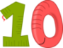
Six  ____________________________________________________________ | Seven  ____________________________________________________________ | Eight  ____________________________________________________________ | Nine  ____________________________________________________________ | Ten  ____________________________________________________________
2. Write. Yaz.
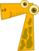  _______________ |   _______________ |   _______________ |   _______________ | 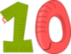  _______________
  _______________ | 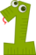  _______________ |   _______________ |   _______________ | 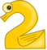  _______________
3. Write.
_______________ | 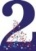  _______________ |   _______________ |   _______________ |   _______________
  _______________ |   _______________ |   _______________ |   _______________ | 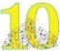  _______________
4. Write.
  _______________ |   _______________ |   _______________ |   _______________ |   _______________
  _______________ |   _______________ |   _______________ |   _______________ |   _______________

5.
_______________ | _______________ | _______________ | _______________ | _______________
_______________ | _______________ | _______________ | _______________ | _______________

5. Write.
Sözcükleri tamamlayınız ve yandaki bulmacada bulunuz.

Z_ _ _ O_ _ T_ _ T_ _ _ _ F_ _ _

F_ _ _ S_ _ S_ _ _ _ E_ _ _ _ N_ _ _

T_ _

WORDSEARCH

E | F | O | U | R | N | F
T | E | R | F | H | T | E
N | E | E | I | G | H | T
T | N | Z | V | E | R | E
X | I | S | E | V | E | N
N | E | N | O | N | E | I
E | W | O | W | T | E | N

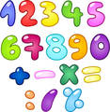
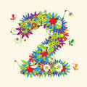
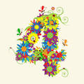
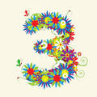

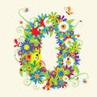

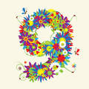
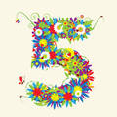
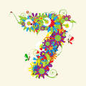
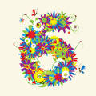
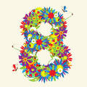

MATCH Eşleştiriniz. ONE
SEVEN
ZERO
EIGHT
NINE
SIX
THREE
FIVE FOUR TWO

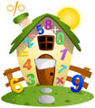

WRITE THE ANSWERS IN WORDS

=
4
+
6
=
=
=
=
=
3
2
1
3
2
+
-
+
-
+
3
10
7
9
5

Count and write. Say ve yaz.
 | _________  books |  | _________  balloons
 | _________  eggs |  | _________  balls
 | _________  blocks |  | _________  apples

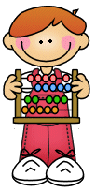



Complete the crossword

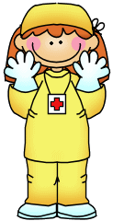
1
2
3
4
5
6
7
8
9




6










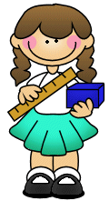


Hüseyin GÜLER
Teacher of English

