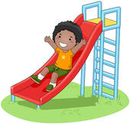
SWINGING SLIDING

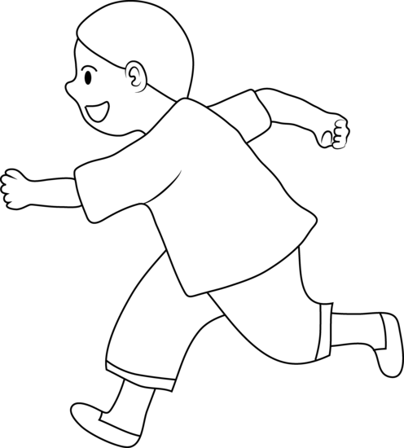
RUNNING WALKING
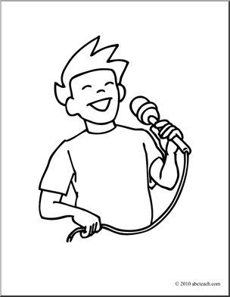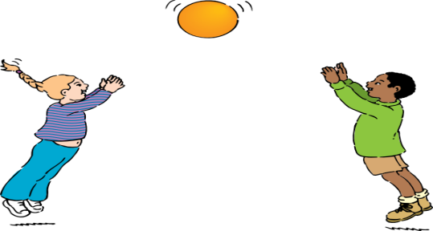
SINGING PLAYING
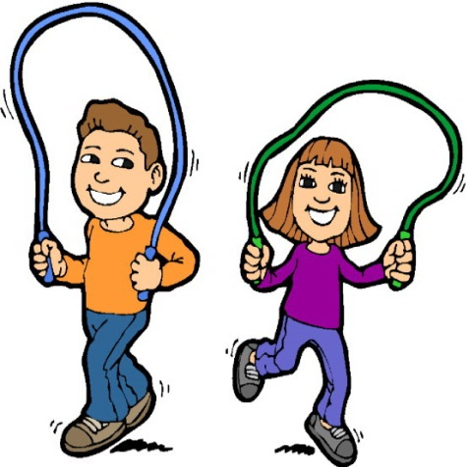
SKIPPING A ROPE JUMPING
A.
LET’S 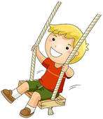_________________! LET’S 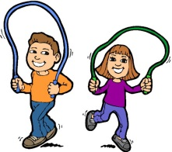_________________!

LET’S 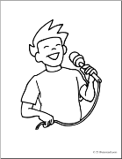 _____________________! LET’S ______________________!

LET’S 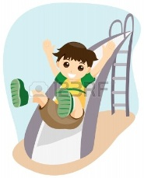___________________! LET’S _______________________!

LET’S 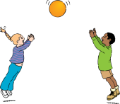______________________! LET’S 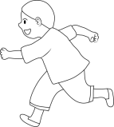_______________________!
B. …………………………………………………………………………………………………………………………………………………….................................................................
-DO YOU_____________?() - DO YOU__________? (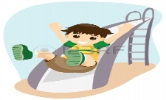)
-YES, I _________. - NO, I __________.

-DO YOU_____________?() - DO YOU__________? ()
-YES, I _________. - NO, I __________.

