Hello! My name is Tweety. I am a ……………….

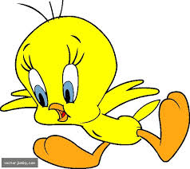
Hi!. I am a Ninja. I am a ……………….

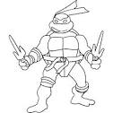
Hi!. I am Kitty. I am a ……………….
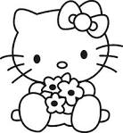
Hello! My name is Bugs Bunny. I am a …………..

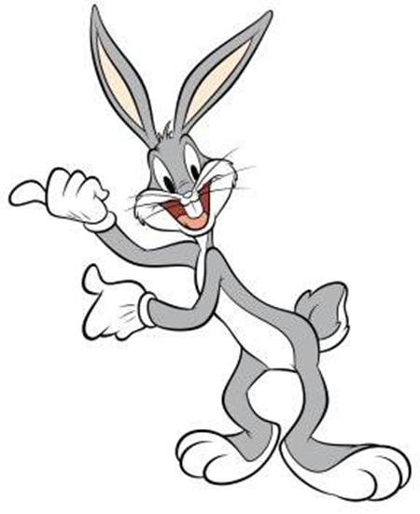
Hi!. I am Jerry. I am a ……………….
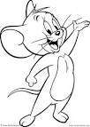
BİLGE AKMAN
ENGLISH TEACHER

