Resme uygun şıkkı işaretleyin.
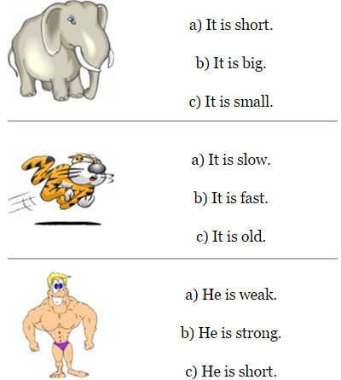
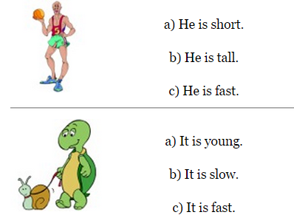
Sayıların İngilizcelerini yazın.
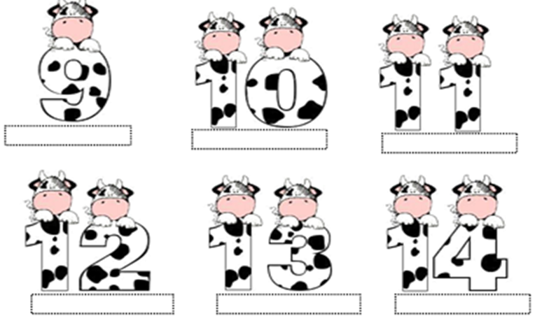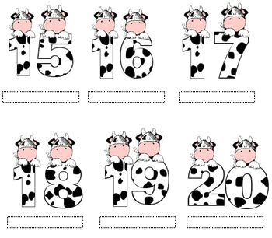

How do you feel?(Nasıl hissediyorsun?)
Resme uygun şıkkı işaretleyin.

- I feel surprised. a) I am sad.
- I feel angry. b) I am angry.

- I feel energetic. a) I am happy.
- I feel angry. b) I am sad.

- I am tired. a) I am hungry.
- I am good. b) I am bad.
UNIT 4 (Şu anda gerçekleştirdiğimiz eylemler)
Verilen kelimeleri kullanarak soru sorun ve cevaplayın.
(eat-study-sing-cook-cry-swim)
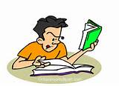
- What is he doing? -What is she doing?
- He is studying. -…………………………………

-…………………..……….? -……………………………………?
-……………………….…... -……………………………….…..
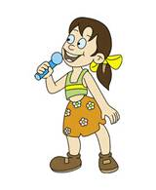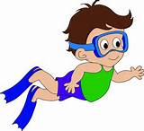
-…..………………………………? -…………………………………….?
-……………….……………………. -…………………………………….

MY FAMILY
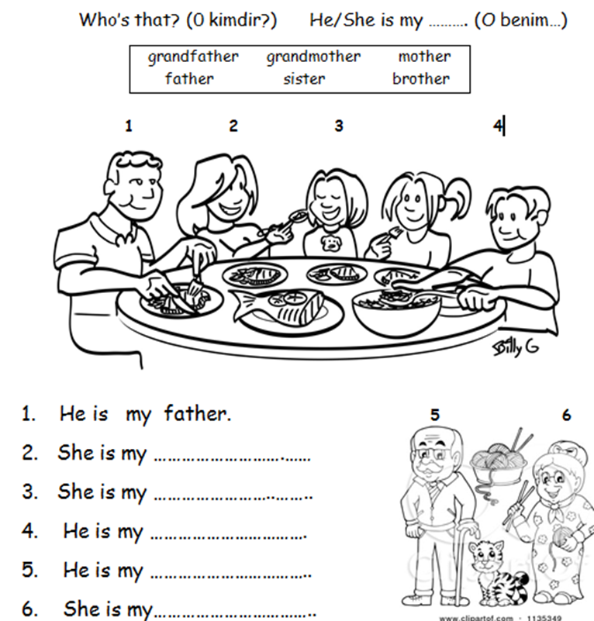

WHEEL OF FORTUNE
Resme uygun ifadeyi işaretleyin.
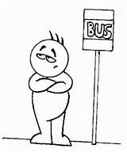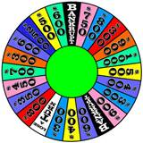

- Win a) Answer a)Wheel
- Wait b) Letter b)Start
- Spin c) Stop c)Win


- Ask a) Start a) Win
- Start b) Stop b) Letter
- Win c) Spin c) Wait

Abilities (Can /Can’t) –e bilmek/-e bilememek
Resimlere bakın, verilen kelimelerle can ve can’t kullarak cümleler kurun.
(run fast - climb a tree – play the piano – jump)


She can swim. He can’t ride a bike.
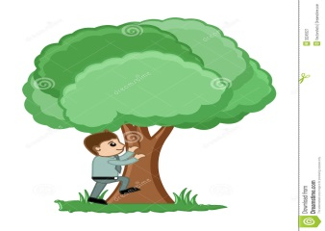
……………………………… …………………………………………
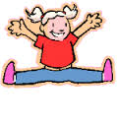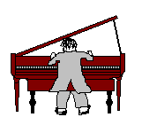
………………………… …………………………………….



100.YIL PRIMARY SCHOOL
My English
Booklet
3/A -3/C -3/E -3/G- 3/J-3/L- 3/N- 3/Ö GRADES

My name is ………………………………………………..

TEACHERS: ÖZLEM ZORLU
Have a nice winter holiday!!

EXERCISE : Answer the questions -Soruları cevaplayınız.
- Is it square? 2. Is it rectangle?
------------- ----------------
3. Is it oval ? 4. Is it triangle ?
------------------- ---------------------
HOW MANY………? -Kaç tane……?
1.How many trains are there?………………………
2.How many balls are there ?.............
3. How many cars are there?...................
4. How many robots are there ?.................
Do you have a/an……….? : Bu soru kalıbı bir kişinin bir şeye sahip olup olmadığını sormak için kullanılır.
Example: Do you have a bike? – Yes, I do.
Do you have a teddy bear ? – No, I don t.

Answer the questions - Soruları cevaplayınız
1. Do you have a train ?(+) ……………………………………………………...
2. Do you have a kite? (-) …………………………………………………..
3. Do you have a board game? (+) ……………………………………..
4. Do you have a truck ? (-) ………………………………………………….
5. Do you have plane ? (-) ……………………………………………..
6. Do you have a doll ? (+) …………………………………………………….

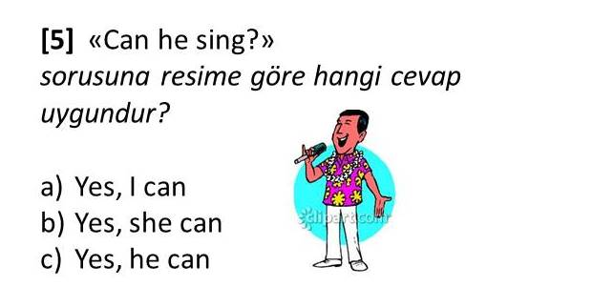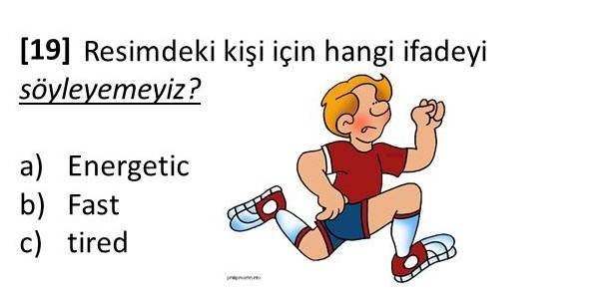
2
1

3.YİRMİ : ..................
A)Nineteen B)Twenty C)Twelve
4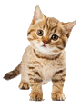:.........is my cat.
A)She B) He C)It

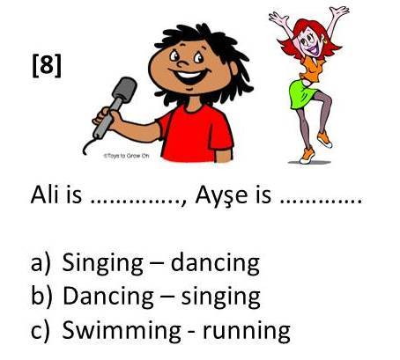
5
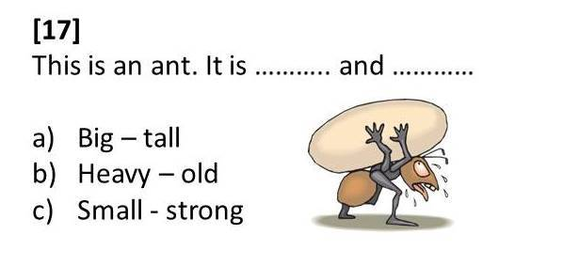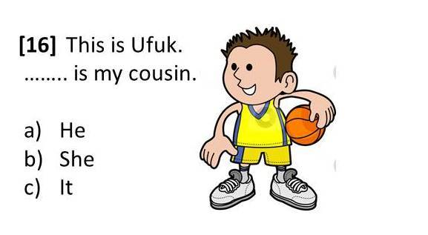
7
6
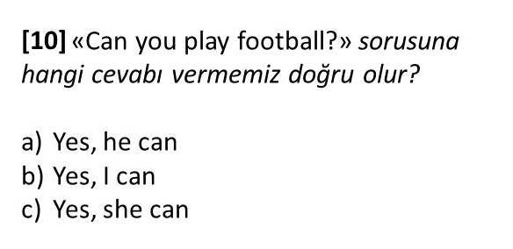
8
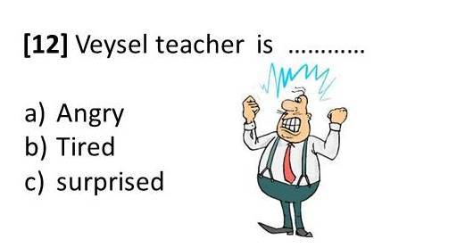10. 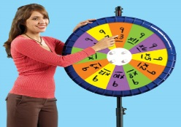 Resmi anlatan ifade hangisidir?
9
A)ask a question b)wait your turn c)spin the wheel d) spell it

11)Look! She.................mysister.
A)Are B) Is C)It
12. “ __OOK” kelimesinin ilk harfi hangisi olmalıdır?
a) T b) C c) W d) H

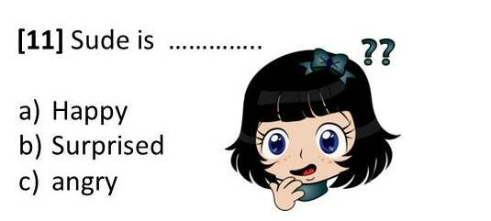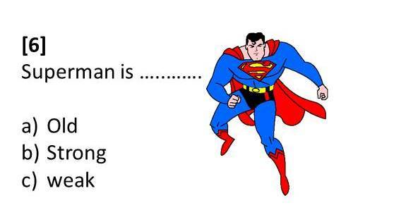
14
13

