NAME:
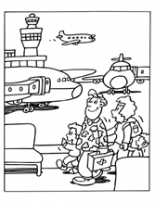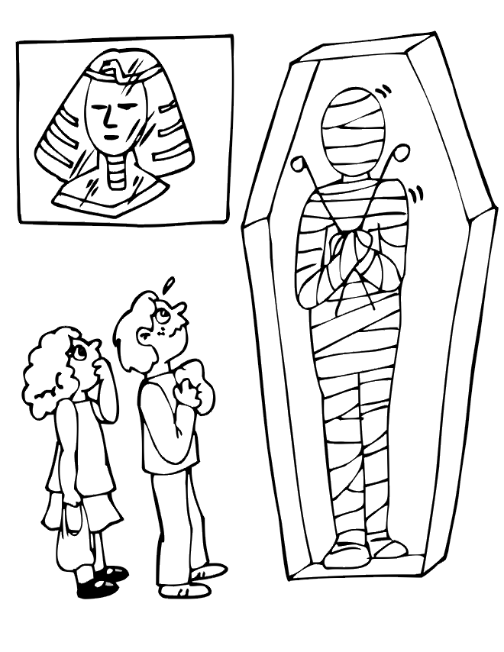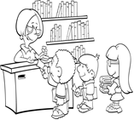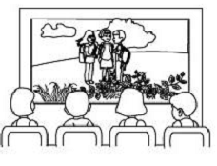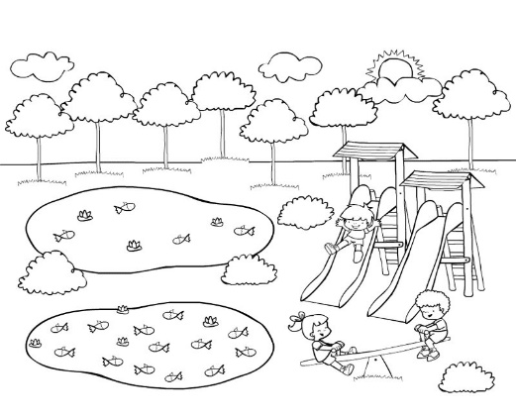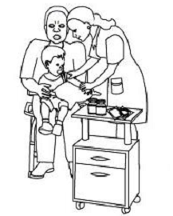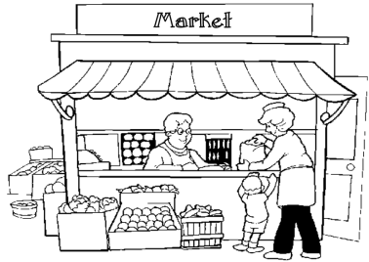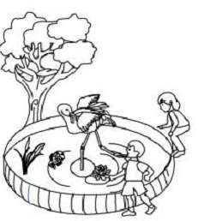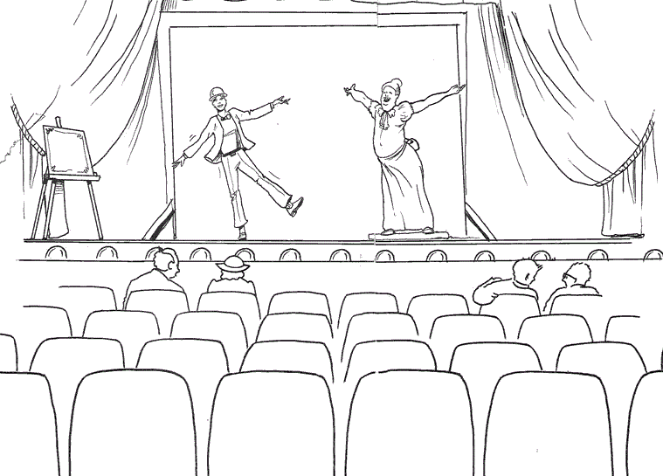Onlar neredeler? ( resimlerin altındaki doğru şıkkı yuvarlak içine alınız.)
At the airport
At the library
At the zoo
At the post office
At the library
At the museum
At the post office
At the library
At the museum
At the shoping centre
At the zoo
İn the park
At the hospital
At the zoo
At the cinema
At the shoping centre
At the school
İn the park
At the hospital
At the zoo
İn the park
At the bank
At the cinema
İn the park
At the hospital
At the zoo
At the theater
At the hospital
At the zoo
At the cinema

