QUIZ FOR THE 3rd GRADES

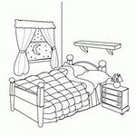
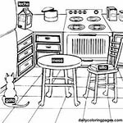
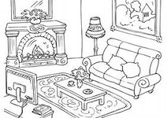
1-

Yukarıdaki resimlere göre aşağıdaki sıralamalardan hangisi doğrudur?
a) kitchen – bedroom – living room
b) bedroom – kitchen – living room
c) living room – kitchen – bedroom
d) living room – bedroom – kitchen

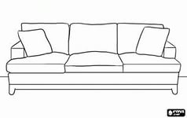
2- Resme uygun seçenek
hangisidir?
a) sofa b) chair
c) bed d) table

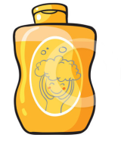
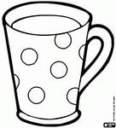
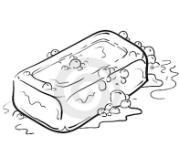
3-

Yukarıdaki resimlere göre aşağıdaki sıralamalardan hangisi doğrudur?
a) cup – shampoo – soap
b) soap – shampoo – cup
c) shampoo – soap – cup
d) soap – cup – shampoo

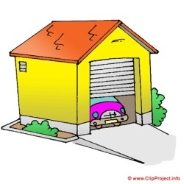
4- Where is the car?
a)Yes,it is.
b)It is in the garage.
c)No, it isn’t.
d)It is in the bathroom.

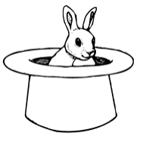
5- A: Where is the rabbit?
B: It is……………..the hat.
a)on b)in
c)under d)next to
6- A: Where is the teddy bear?
B: It is …………the box.
a)on b) behind
c) in front of d) between

7- A: Where is the box?
B:It is ……….the teddy bears.
a) in b) next to
c) between d) behind

8- A: Where is the teddy bear?
B: It is ………………the box.
a) on b) in front of
c) under d) behind
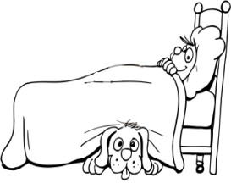
9- A:Where is the dog?
B:It is………….the bed.
a) in b) on
c) under d) near

10-

Yukarıdaki resimlere göre aşağıdaki sıralamalardan hangisi doğrudur?
a) puzzle – kite – board game
b) kite – board game – puzzle
c) board game – kite – puzzle
d) puzzle – board game – kite
11-

How many robots are there?
a)eleven b) ten c) eight d) twenty


12- The ball is…………………
a) square b) triangle
c) rectangle d) round

13- “purple – blue – yellow – white – red”
Yukarıda verilmeyen renk hangisidir?
a)mor b) kırmızı c) sarı d) siyah


14- What is she doing?
a) She is cooking.
b) She is eating.
c) She is crying.
d) She is studying.

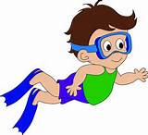
15- Is he swimming?
a)Yes, he is.
b) No, he isn’t.
c) Yes, she is.
d) No, she isn’t.



16-

Yukarıdaki ifadeler hangi şıkta sırasıyla doğru verilmiştir?
a) tired – surprised – sad
b) tired – happy – surprised
c) angry – sad – happy
d) energetic – surprised – sad

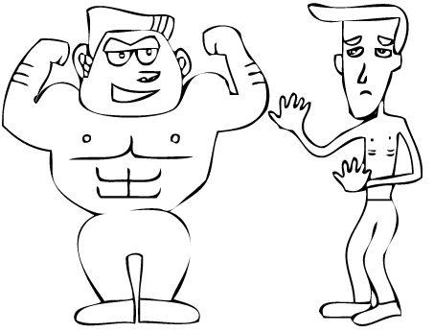
17- Resmi ifade eden zıt
anlamlı kelimeler
hangisidir?
a) fast x slow
b) strong x weak
c) tall x short
d) fat x thin

18- He is my ……………………….
a) grandmother
b) aunt
c) grandfather
d) sister

19- “twelve – sixteen – nine – twenty”
Yukarıda verilmeyen sayı hangisidir?
a)yirmi b)on altı c) dokuz d) on üç

20- “Cevap verebilir miyim?” sorusunu nasıl sorarız?
a) Can I answer? b) Can I ask?
c) Can I say? d) Can I go?

21- A: Can you play football?
B: ……………………………………..
a) Yes, he can. b) No, he can’t.
c) Yes, I can. d) No, she can’t.


22- Resimde hangi eylem
anlatılıyor?
a) wait b) stop
c) win d) spell

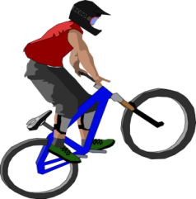
23- Yandaki görsele uygun
cümle hangisidir?
a) I can drive a car.
b) I can ride a bike.
c) I can climb trees.
d) I can ride a horse.
24- BIG X …………. Kelimesinin zıt anlamlısı hangisidir?
a) young b) tall c) fast d) small
25- A: Where is Egemen?
B:……………………………………………
a) He is in the bedroom. b) He is thin.
c) Yes, he is. c) He is seven.
GOOD LUCK

