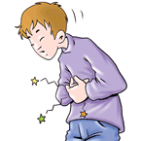  1. Tom: What’s the matter with him?  Mary: He has a stomachache.  Tom: What should he do?  Mary: He should take a medicine. | 9. Tom:_______________________  Mary: _______________________  Tom:_______________________  Mary:_______________________
2. Tom: What’s the matter with her?  Mary: She has a cold.  Tom: What should she do?  Mary: She shouldn’t drink cold water. | 10. Tom:_______________________  Mary: _______________________  Tom:_______________________  Mary:_______________________
3. Tom:_______________________  Mary: _______________________  Tom:_______________________  Mary:_______________________ | 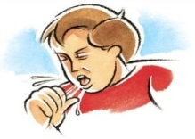  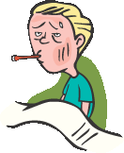  11. Tom:_______________________  Mary: _______________________  Tom:_______________________  Mary:_______________________
4. Tom:_______________________  Mary: _______________________  Tom:_______________________  Mary:_______________________ | 12. Tom:_______________________  Mary: _______________________  Tom:_______________________  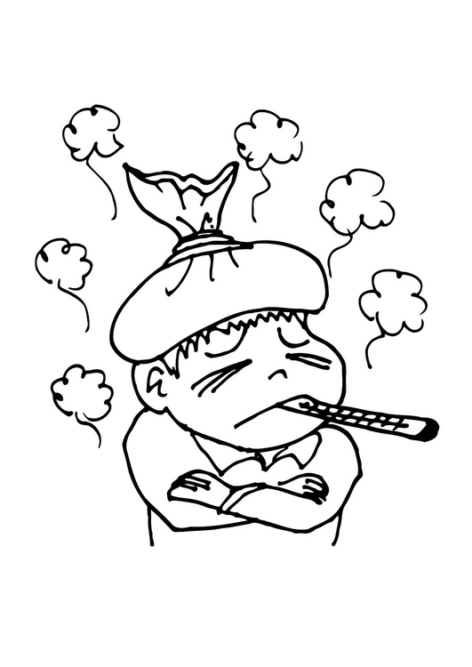  Mary:_______________________
5. Tom:_______________________  Mary: _______________________  Tom:_______________________  Mary:_______________________ | 13. Tom:_______________________  Mary: _______________________  Tom:_______________________  Mary:_______________________
6. Tom:_______________________  Mary: _______________________  Tom:_______________________  Mary:_______________________ | 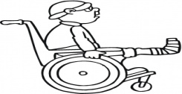  14. Tom:_______________________  Mary: _______________________  Tom:_______________________  Mary:_______________________
7 . Tom:_______________________  Mary: _______________________  Tom:_______________________  Mary:_______________________ | 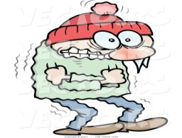  15. Tom:_______________________  Mary: _______________________  Tom:_______________________  Mary:_______________________
8. Tom:_______________________  Mary: _______________________  Tom:_______________________  Mary:_______________________ | 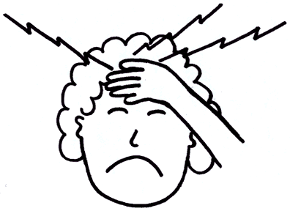  16. Tom:_______________________  Mary: _______________________  Tom:_______________________  Mary:_______________________
SUGGESTIONS (TAVSİYELER)
*Eat vegetable and fruit * take medicine * see a dentist * don’t eat sweets
*Have a rest * take a painkiller * don’t go to school * sleep
*Have your meal regularly * stay in bed * don’t drink cold water * lie in the bed
*Get some fresh air * stay at home * don’t eat fast food * brush your teeth
*Do sports * see a doctor * don’t drink fizzy drinks * wash your hands
*Wear thick clothes * take vitamin C * have hot drinks * take a cough syrup
NEED (ihtiyacı olmak)
*painkiller *medicine *plaster *pill *tissue *cough syrup
*thick clothes *blanket *herbal tea *hot drinks

- I have a runny nose. I need some _________________.
- I have a sore throat. I need _____________________.
- She has a cold. She needs _____________________.
- He has a broken arm. He needs _____________________.
- I have a stomachache. I need ______________________.
- She has a headache. She needs ____________________.
- He has flu. He needs _____________________-.
- I have a cold. I need a _____________________.
- I have a terrible cough. I need some ___________________.
- I’m ill. I need some _______________________.

FEEL (hissetmek)
*sick *unhappy *cold *tired *angry

- I feel _______________ so I need Vitamin C.
- She feels _______________ because she has the measles.
- He feels _______________. He should see a doctor.
- I have a broken leg and I can’t walk so I feel ______________.
- Emir feels _______________ so He needs a blanket.

1)HAND 3)LEG 5)FOOT 7)ARM 9)MOUTH
2)EYE 4)EAR 6)HAIR 8)NOSE

