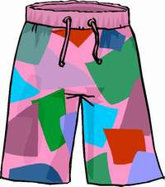 | 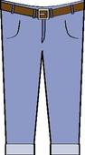 | 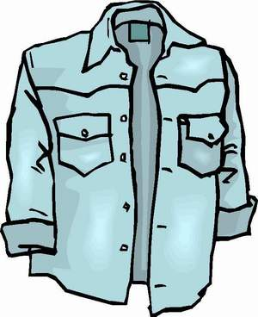 | 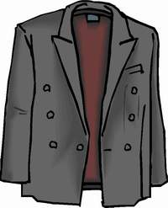 | 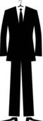
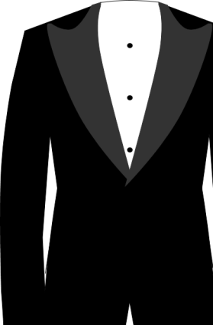 | 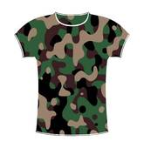 | 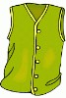 |  | 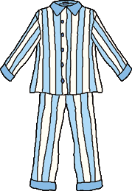
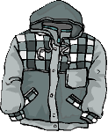 | 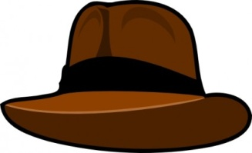 | 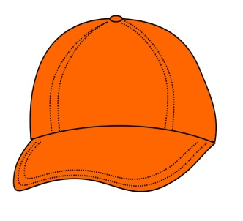 | 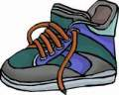 | 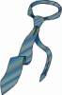
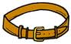 | 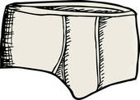 | 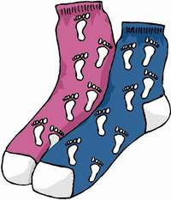 | 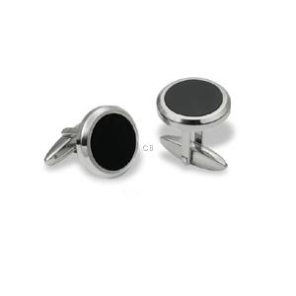 | 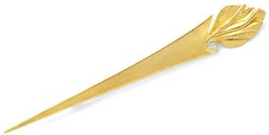

SHORTS  BERMUDAS | HOSE | HEMD | SAKKO | ANZUG
SMOKING | TSHIRT | WESTE | SWEATSHIRT | PYJAMA
ANORAK | HUT | KAPPE | TURNSCHUHE | KRAWATTE
GÜRTEL | UNTERHOSE | SOCKEN | MANSCHETTEN  KNÖPFE | KRAWATTEN-NADEL

