HACI SEVİM YILDIZ-1 MESLEKİ VE TEKNİK ANADOLU LİSESİ 2014-2015 EĞİTİM-ÖĞRETİM YILI
10.SINIFLAR 1.DÖNEM 1. YAZILI SORULARI
Name-surname : ………………………………….. No : …………… Class: 10/ ……… Mark:……………………GoodLuck
A.Answerthequestions.(Sorulara uygun cevaplar veriniz.)(3*3:9P)
1-What is your name?..........................................................................................................
2-Where areyou from?.......................................................................................................
3-How oldare you?................................................................................................................
B.Fill in theblankswithusing “Simple Present Tense”(Boşlukları doldururken “geniş zaman” kullanınız) (5*3:15P)
1)She…………………..(play)football(-)
2)l…………………………...(do)myhomework(+)
3)They…………………(go)toschool(-)
4)He …………………………(live)in Moscow.(+)
5)It…………………........(run)fast(+)
C.Orderthesentences.(Aşağıdaki cümleleri düzenli cümle haline getiriniz.)(5*3:15P)
1)live/in the USA/you/do (?)…………………………………………………………………………..
2)l/music/listen/to(+)…………………………………………………………………………………….
3)She/does/book/read/not(+)…………………………………………………………………..
4)They/TV/watch/not/do(-)…………………………………………………………………………..
5)He/toschool/does/go(?)………………………………………………………………………………
D. Write theTurkishmeanings. (Aşağıdaki cümlelerin Türkçe anlamlarını yazınız.) (5*2:10P)
1) How is it going? :…………………………………………………………………………………….
2) Takecare. :……………………………………………………………………………………………..
3) Seeyoulater! :………………………………………………………………………………………
4)Have a nice day. :…………………………………………………………………………………………
5) Goodmorning. :…………………………………………………………………………………………………

E.Matchthejobswiththepictures. (Resimlerle meslekleri eşleştiriniz.)(6*2:12P)
chefteacherdoctorreporterweathercastersecretary
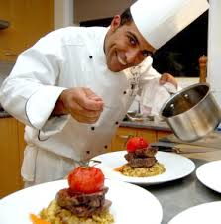

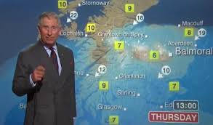
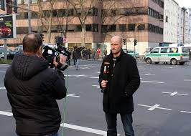


………………………………………………………………………………………………………………….……………………………….
F. Matchtheactivitieswiththephotos. (Resimlerle aktiviteleri eşleştiriniz.)(8*3:24P)
playingfootball - reading a book - watching TV - playingbasketball - doinggardening
cooking - dancing - playing a musicalinstrument


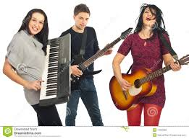
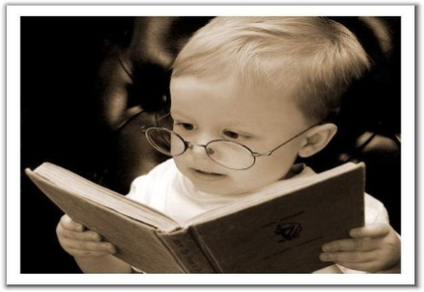


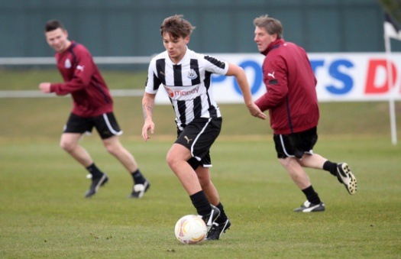
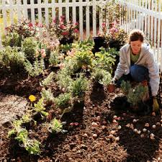

G

G.Matchtheanswerwiththequestions.(Cevaplarla soruları eşleştiriniz.)(7*2:14P)
1)Where is the Eiffel Tower? a) Bert Costa
2)How oldareyou? b) FromMoscow.
3)What do you do? c) I am a technician.
4)Where do youcomefrom? d) Seventeen.
5)What’syour e-mail adress? e)It is in Paris.
6)Can I haveyour name? f)It’s
7)What’syouradress? g)310 Percy Street, New York

