2017-2018 EDUCATIONAL YEAR PETROL SECONDARY SCHOOL
1ST TERM 1ST ENGLISH EXAM FOR 6TH GRADES
NAME_________________CLASSS_____________NUMBER____________
- Match the phrases to the pictures (kelimeleri uygun resmin altına yazınız ) (6*4=24)
play soccer | go online | watch TV | do karate | have a rest |  | take guitar courses
 |  | 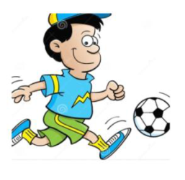

B. Aşağıdaki cümleleri “in”,“on”, veya “at” kullanarak tamamlayınız.(7x2=14 pts.)
- I go to the cinema with my friends ____ Sundays.
- We play table tennis ____ the weekend.
- Andy and Bill go on holiday ____ summer.
- My sister gets up ____ 07:00 a.m.
- Tina sleeps late ____night.
- My brother does his homework ____ the afternoons.
- Linda and George plays basketball ____ Saturday mornings.

C )Aşağıdaki saatlerin kaç olduğunu yazınız.(6x3=18 pts.)
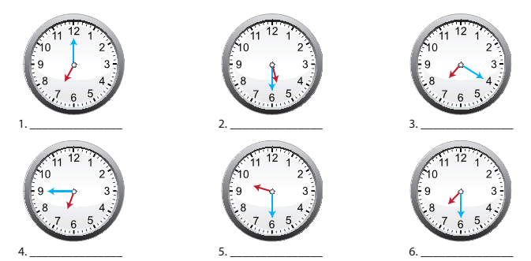

D)Aşağıdaki soruları cevaplarıyla eşleştiriniz.(5x3=15 pts.)
- What time do you go to bed? ___ a) In İstanbul.
- Where does Eda live? ___ b) At 7 p.m.
- Why do you wake up early? ___ c) Because I go to work early.
- How often do you meet your friends? ___ d) Often.
- When does she go to the dance club? ___ e) On Saturdays.

- Aşağıdaki kelimeleri sıraya koyarak cümleler oluşturunuz.(5x3=15 pts.)

- watch / tv / I / usually ……………………………………………………
- Jane / listen / music / doesn’t / to / everyday …………………………………………………...
- We / a / have / after / rest / school …………………………………………………...
- Do/my/ ın/ the / evening / homework / ı ……………………………………………………
- you / volleyball / Do / play / Sundays / on / ? ………………………………………………...

- Aşağıdaki kelimelerin Türkçe anlamını yazınız. (5*3=15)
Meet friends -
Go to dance club -
Have breakfast -
Do homework -
Go to bed-
Good luck
Teacher of English

