Boşluklara sırasıyla uygun düşen sözcük ya da ifadeyi bulunuz.
- January, ______, March, _______.
- April/February
- February/April
- July/August
- November/December
- Ten,_____, twelve, _____fourteen.
- thirteen/ fifteen
- nine/eleven
- twenty/thirteen
- eleven/thirteen
- Tuesday, _____Thursday,______.
- Sunday/Monday
- Wednesday/Friday
- Saturday/Sunday
- Monday/Wednesday
- Spring, _____autumn,_______.
- Sunday/winter
- Wednesday/summer
- Winter/summer
- Summer/winter
- I_____ bagel, but I ______ croissant.
- loves/likes
- doesn’t like/love
- like/hates
- love/don’t like
- Tarkan goes to school ___ weekdays.
- on
- at
- in
- ---
- We have a big breakfast ___weekends.
- on
- at
- in
- ---
- I leave home ___7.30a.m
- ---
- in
- on
- at

- A: ____you____ your homework before dinner?
B: No, I ____. I ____ my homework after dinner.
- Do/do/do/do
- Do/do/don’t/do
- Do/do/do/don’t
- Don’t/do/don’t/do
- Farklı olan kelimeyi bulunuz.
- Milk
- Cereal
- Coffee
- Tea
- Aşağıdakilerden hangisi “ DRINK” kelimesine örnek değildir?
A) Orange
B) Coke
C) Water
D) Orange juice
12) Görseli anlatan şıkkı işaretleyiniz.
a) watch TV
b) have a snack
c) go online
d) rest


13) My father __________ a lot of fruit and vegetables.
Cümleyi tamamlayan şıkkı işaretleyiniz.
- eat
- don’t eat
- eats
- eating

14) -What _____ you ____ now?
-I am _____ the first English exam now.
- is/do/ take
- are/does/takes
- are/doing/taking
- is/doing/taking

Match the sentences with the pictures. (Saatleri eşleştiriniz ve cevap anahtarına kodlayınız.)
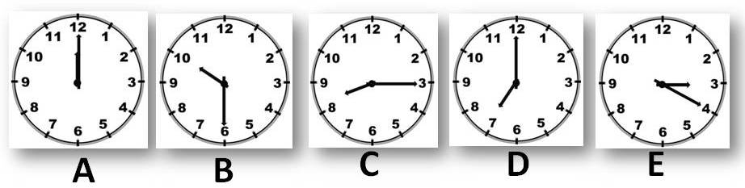
Ex: I arrive home at twenty past three. __E__
15) I go to school at quarter past eight.____
16) I have lunch at twelve o’clock. _____
17) I get up at seven o’clock ______
18) I go to bed at half past ten. ______

19) Görseli anlatan şıkkı işaretleyiniz.
a) Coffee
b) Orange juice
c) Apple
d) Pancake

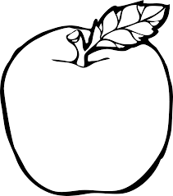

20) Hangisi kitabımızdaki ilk üç ünitenin isimlerinden biri değildir?
- After School
- Yummy Breakfast
- A day in My City
- Bon Appetit!
21) -_____ is your English teacher?
-Mehmet Emin Yılmaz.
Name:
Surname:
Number:
Class:

- What
- Who
- Where
- What time

22) - What ___ your name?
- ___ name is Muzaffer.
- is/your
- are/you
- is/my
- is/his
23) İngilizcede’ afiyet olsun’ ne demektir?
- Enjoy your meal!
- Guten appetite!
- Buono appetito!
- Bon appétit!
24) -_____ do you go online at weekends?
- Sometimes.
- How
- How often
- What time
- When
25) Halay is _____ dance in Turkey.
SORU | SEÇENEK
1 | A | B | C | D
2 | A | B | C | D
3 | A | B | C | D
4 | A | B | C | D
5 | A | B | C | D
6 | A | B | C | D
7 | A | B | C | D
8 | A | B | C | D
9 | A | B | C | D
10 | A | B | C | D
11 | A | B | C | D
12 | A | B | C | D
13 | A | B | C | D
14 | A | B | C | D
15 | A | B | C | D
16 | A | B | C | D
17 | A | B | C | D
18 | A | B | C | D
19 | A | B | C | D
20 | A | B | C | D
21 | A | B | C | D
22 | A | B | C | D
23 | A | B | C | D
24 | A | B | C | D
25 | A | B | C | D
- Polka
- nutritious
- Flamenco
- traditional

