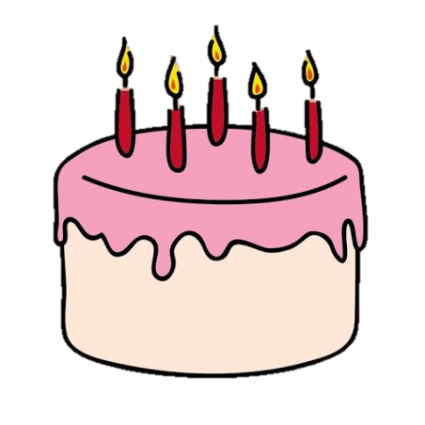
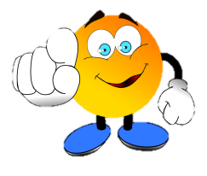
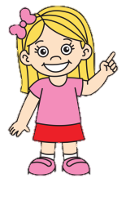




WE LOVE ENGLISH
HOW OLD ARE YOU?
I AM ____ YEARS OLD.
Let’s talk about you!
What’s your name?
-
How old are you?
-
Where are you from?
-
How are you today?
-
_____________ Clara.
Hello. ________?

Hello! My name is Matt. What’s your name?
Nice to meet you.
GREETINGS!
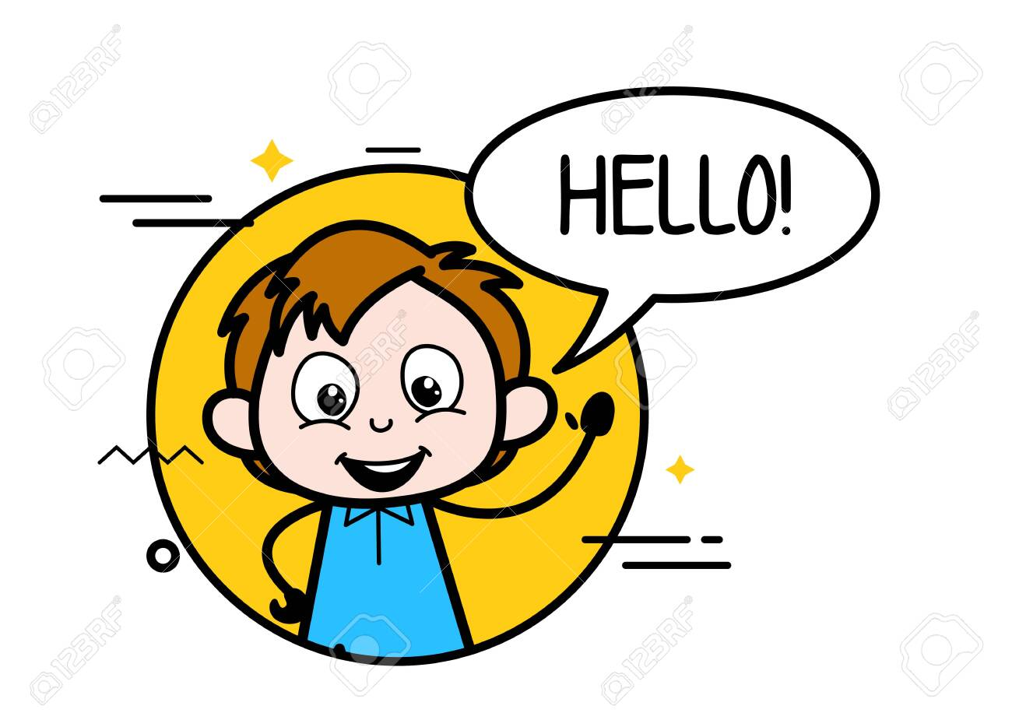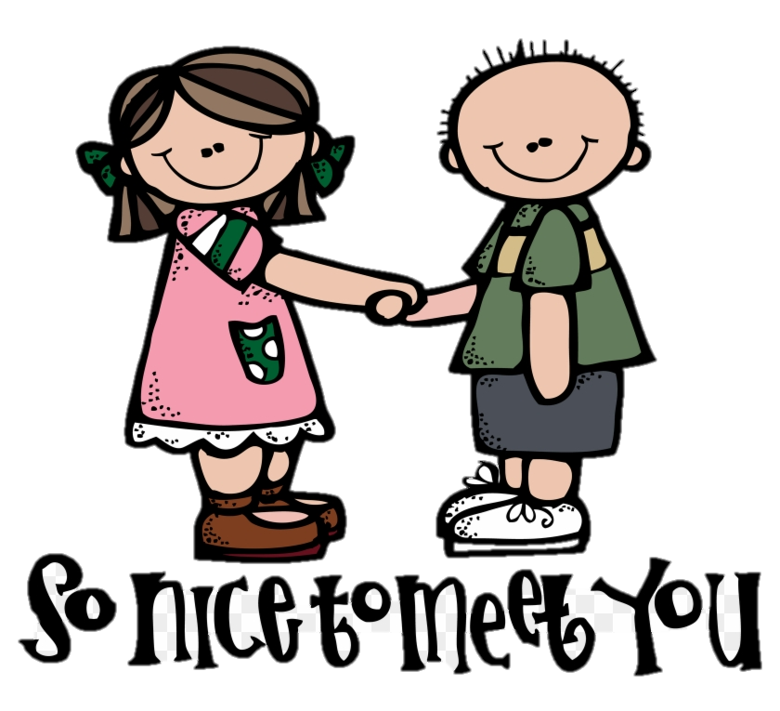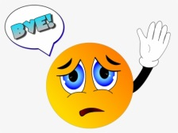
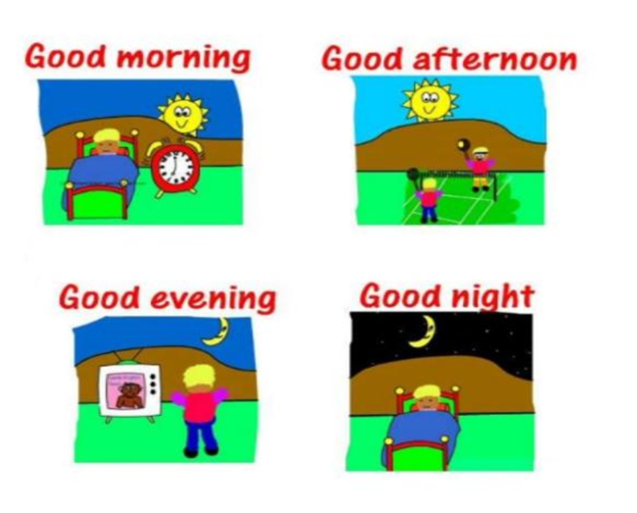
yellowflicker
NUMBERS (FROM 1 TO 20)
1=
2=
3=
4=
5=
6=
7=
8=
9=
10=
11=
12=
13=
14=
15=
16=
17=
18=
19=
20=
BACK TO SCHOOL

