Name & Surname:
Class: 2014-2015 Academic Years,
Hüseyin Çorum Vocational and Technical Anatolian High School,
English Lesson, Grades 11, 1st Term, 2nd Exam Questions
READING ( 15 POINTS )
The Rodriguez Brothers Circus is in town! Every year, the circus arrives and stays for a week. Then they go to the next town.
There are not many animals in the circus. People told the circus that they didn't like seeing animals performing. There is an elephant called Jacob and two old lions, Hattie and Meg.
Most of the performers are human! There is Jack, The Strongest Man In The World. His father also worked in the circus, but Jack is stronger than his father, he has bigger arms and bigger legs too! Jack performs his act every night for the town's people who come to watch.
Another performer is Clara. She says she has the longest hair in the world. It's about 4 metres long! She also has a daughter who works in the circus. Her name is Sue-Ellen. Her hair is shorter, but she wants to grow it as long as her mother's. Sue-Ellen helps look after the animals.
The highlight of the circus are the three clowns, Pit, Pot and Pat. They all wear long red shoes, but Pat's shoes are the longest and sometimes, he falls over because they're so long! They perform for about twenty minutes and they are always the most popular act with the audience, especially the children. Many people think Pit, Pot and Pat are three brothers, but Pat is older than the other two - he's their father! He's the oldest clown in the country, but he has a lot of energy.
Tomorrow will be the longest, most tiring day because the circus is leaving town and everything must be packed away into big trucks.

A. Read the text and mark sentences T (True) or F (False) (…………/ 5 points)
1. The circus comes to the town every year. ( )
2. There are a lot of animals in circus. ( )
3. Jack's father is the strongest. ( )
4. The three clowns wear same colour shoes. ( )
5. Clara's hair is longer than her daughter's hair. ( )

B. Answer the questions (………./10 points)
1. How long does the circus stay in a town? ………………………………………………………………………………………………………………
2. How many clowns are there in the circus?
………………………………………………………………………………………………………………
3. Which clown is older than others?
........................................................................................................................................................................
4. Who is Sue-Ellen?
………………………………………………………………………………………………………………
5. Is Jacob a human?
……………………………………………………………………………………………………………..

WRITING ( 50 POINTS )

A. Circle the Correct Adjectives (………/10 points)
1. Mary is waiting for his boyfriend, and she is very excited/exciting.
2. It was a bad day. We were all bored / boring.
3. Cheer up. Don’t feel so disappointed / disappointing. There are a lot of other jobs.
4. Yesterday was a tired / tiring day.
5. Their hamburgers are disgusted / disgusting.
6. We were surprised / surprising to hear that he is 50. He looks younger!
7. He was frightened / frightening when he saw a spider.
8. This book is very interested / interesting. I want to read it too.
9. Everybody was shocked / shocking when they heard that Jim had an accident.
10. This place is very depressed / depressing. I don’t like it.

B) Complete The Sentences With A – AN – SOME – ANY – MUCH – MANY (…………/ 20 points)
1. There is ……………. orange on the table. Is it yours?
2. I haven’t got ……………. books. I have got only four.
3. They are my …………….friends from the school.
4. Have you got …………..new friends in town?
5. We haven’t got …………..bread. Go and buy some please.
6. I have got ……………cat. What about you?
7. There are …………people over there. Who are they?
8. How …………… girls are there in your class?
9. We are going to be late.There is too ………………traffic.
10. Would you like …………..wine with your dinner?

C) Complete The Sentences With A FEW– A LITTLE – A LOT OF (…………/ 10 points)
1. We only have……………. carrots. We should go and buy some more.
2. "Do we need any mushrooms?" "No, we have……………… Look, three bags!"
3. When you make the pie, put ………………. wine in too. But not too much! It makes it really tasty.
4. I have ……………. dresses in my wardrobe. I can’t stop it, I always buy one every week.
5. Hurry up! There is ……………….. time to catch the bus.

D) Match the following words with pictures (…………./ 10 points)

grate slice squeeze bake sprinkle boil stir fry chop grill

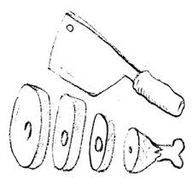

1.___________ 2.__________ 3.__________ 4.__________ 5.___________
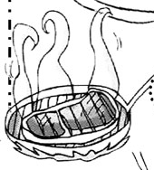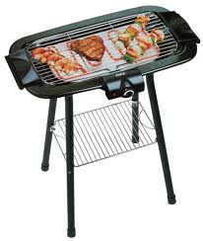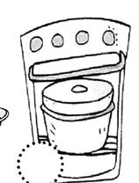

6.___________ 7.__________ 8._________ 9.__________ 10.__________

English Language Teacher English Language Teacher

