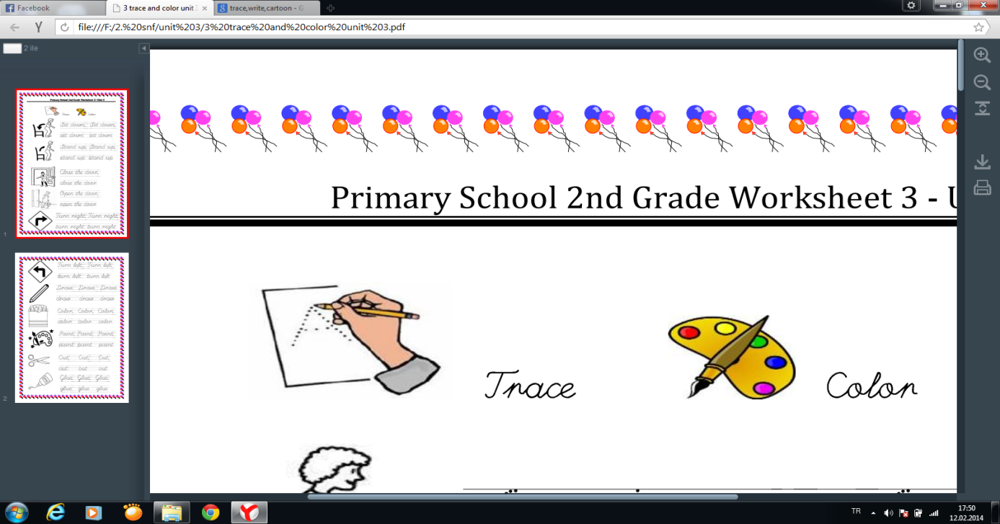
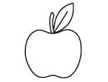
Apple

Banana

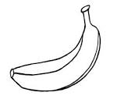

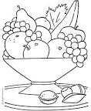
Fruit

Grapefruit

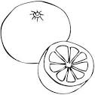

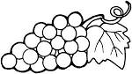
Grape

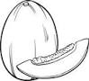
Melon

Orange

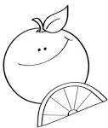

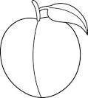
Peach

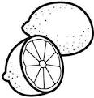
BİLGE AKMAN
ENGLISH TEACHER
Doğru seçeneği işaretleyiniz.
A) melon B) banana C) apple A) grape B) lemon C) apple
A) fruit B) peach C) watermelon A) grape B) orange C) apple
Watermelon

Lemon

