………………………………… ACADEMIC YEAR ……………………. SCHOOL
2nd TERM 2nd WRITTEN ENGLISH EXAM FOR 7th CLASSES
Name, Surname: Grade:
Class:
Number:
A) Batıl inançları resimlerle eşleştiriniz. (8x2,5=20 pts)
seeing a black cat --- walking under a ladder --- opening an umbrella inside --- palm reading
finding four leaf clover --- horseshoe above door --- evil eye --- breaking a mirror
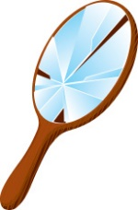
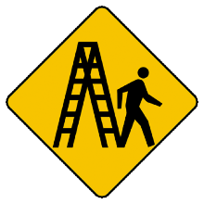
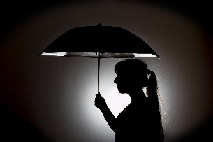
1- 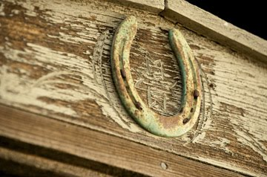 2- 3- 4-
__________ __________ ___________ ____________
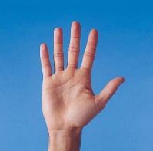
5- 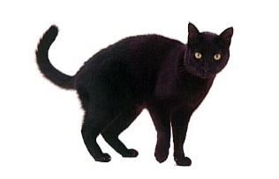 6- 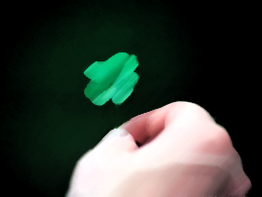 7- 8- 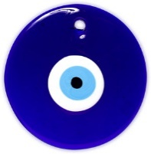
__________ __________ __________ __________
B) Seçeneklerde yer alan öneri ifadelerinden uygun olanını daire içine alınız. (5x4=20 pts)
1- How about / Let’s go to the cinema
2- Why don’t / What about playing computer games
3- What about / Let’s drink something hot
4- We should / How about go to a football match
5- Shall we / How about we go to the library
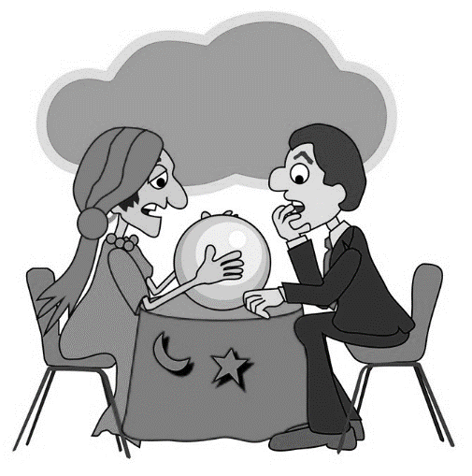
C) Aşağıdaki ifadelerden iyimser tahminleri örnekteki gibi işaretleyiniz. (5x4=20 pts)

You will have a successful career.
You will have some problems in your family.
You will find a good job.
You will lose your best friend.
You will be wealthy.
You will hurt yourself.

D) Aşağıdaki boşlukları uygun kamu binası adıyla doldurunuz. (10x2=20 pts)
pharmacy --- bakery --- gym --- police station --- boutique
florist --- art gallery --- cinema --- bookstore --- zoo

1- I went to ___________________. I bought some bread.
2- She will go to ___________________. She will watch Shrek 3.
3- They went to ___________________. They wanted to see wild animals.
4- My father went to ___________________. He wanted to buy some clothes.
5- You should go to ___________________. You should buy medicine.
6- I went to ___________________. I bought some flower for mum.
7- David will visit ___________________. He wants to buy a painting.
8- I need to go to ___________________. I will buy some books.
9- We went to ___________________. We reported the robbery.
10- Adam goes to ___________________ every day. He wants to have a fit body.

E) Aşağıdaki çoktan seçmeli soruları yanıtlayınız. (5x4=20 pts)
1- Ashley: Do you have _________ number or object? 4- I called ________ because there was
Danny: I have a blue bead. It protects me against a robbery in the street.
the evil-eye. A) fire station
A) superstition B) opera house
B) lucky C) police station
C) fortune teller D) airport
D) scientific

2- She reads coffee cups and people’s palm and tells 5- Cheese cake was _______. I ate three
people about their future. She is a ____________ of them at the shopping mall.
A) fortune teller A) scientific
B) doctor B) delicious
C) writer C) successful
D) therapist D) unlucky
3- This food is ___ hot ___ eat. I can’t eat it.
A) too / too
B) too / to
C) two / to
D) to / to

