carry a rock
read a book

climb a tree
ride a horse

play guitar
swim

drive a car
take a photo

cook meal
catch

play piano
do puzzles

carry a rock
ride a bike

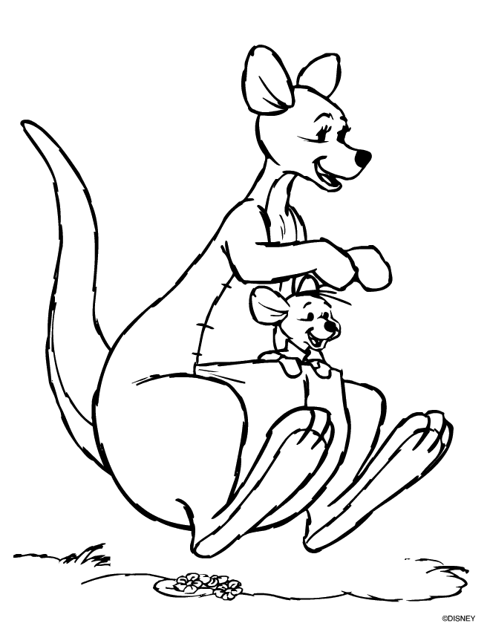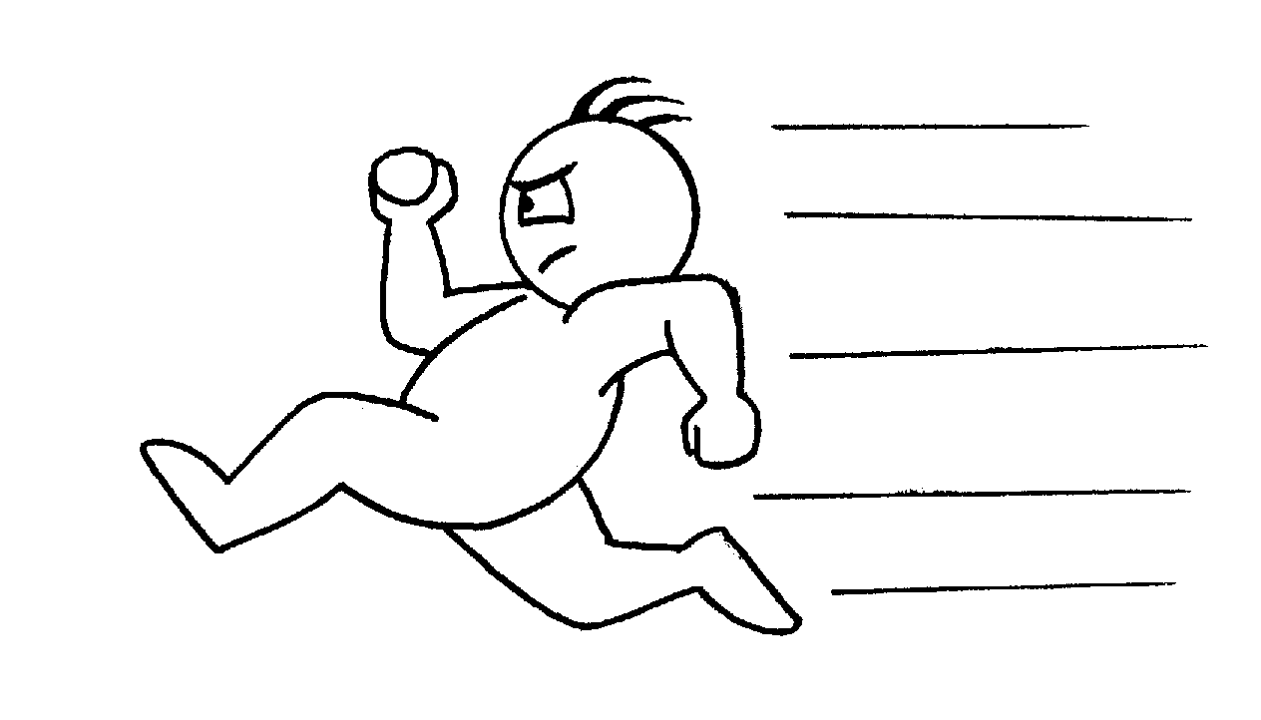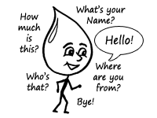
fly
jump
run
speak English

carry a rock
read a book

climb a tree
ride a horse

play guitar
swim

drive a car
take a photo

cook meal
catch

play piano
do puzzles

carry a rock
ride a bike

fly
jump
run
speak English

