continents | Europe | Asia | Africa | Australia | Antartica | South America | North America
countries | England | China | Egypt | New Zeland | - | Brazil | Mexico

A-) 1. Where is China? ………………………………………………… 4. Where is New Zeland?..............................................
2. Where is England?................................................. 5. Where is Mexico?.....................................................
3. Where is Egypt? ……………………………………………….. 6. Where is Brazil?........................................................

B-) 1.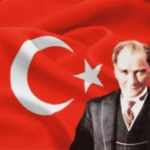 2. 3. 
Where is he from? Where is he from? Where is he from?
4. 5. 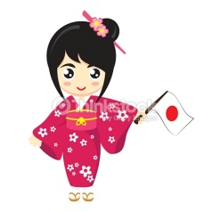 6.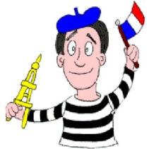
Where is she from? Where is she from? Where is he from?

C- Match the countries with the nationalities.

1-  Russia | 2-Germany | 3-  Indıa | 4-  Portugal | 5-  Canada | 6-  Britain | 7-  Greece | 8-  Italy | 9-  theU.S.A | 10-  Japan
( ) Portuguese | ( )  British | ( )  Japanese | ( )  Greek | ( ) Russian | ( )  Italian | ( )  Canadian | ( )  American | ( )  German | ( )  Indian

D-  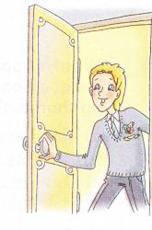 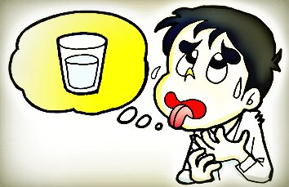 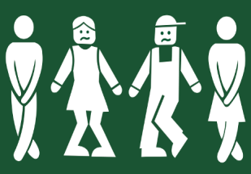 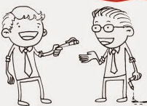

1.May I drink some water? | 2.May I borrow your pencil? | 3.May I come in? | 4.May I use your computer? | 5.May I go to the toilet?

Keep | Don’t | Quiet | Raise | Clean
E- Complete the sentences.

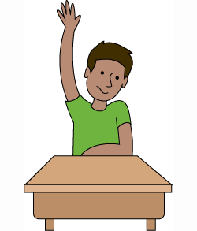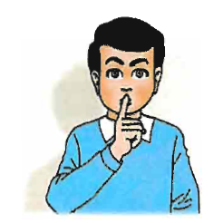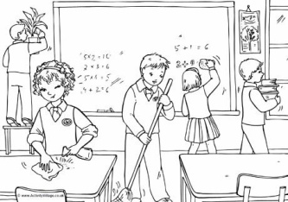
………. your hands up. Be ………… ………your classroom clean. ………….. the board. …….. eat junk food

