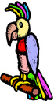
A)KELİMELERİ TAMAMLAYALIM.
Parrot
Parot
Parrout
Turtle
Turle
Turtrle
Fisch
Fish
Fişh
R_d_ a h_rs_
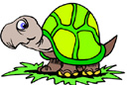
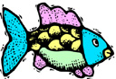
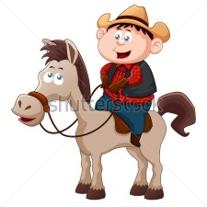

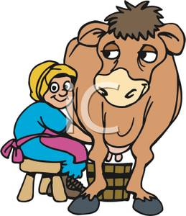
M_lk a c_w
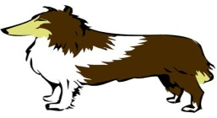 | 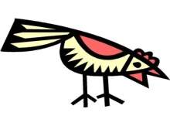 | 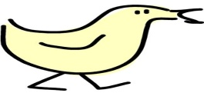
a. poodle  b. dog  c. hound | a. bird  b. cock  c. hen | a. duck  b. kitten  c. chicken
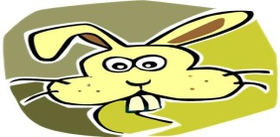 | 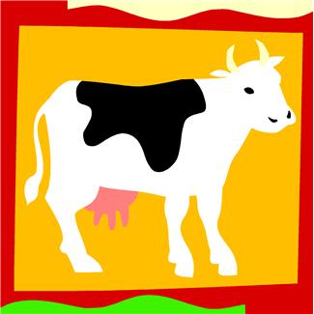 | 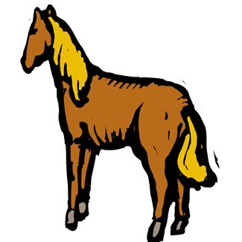
a. rabit  b. rabbit  c. bug | a. veal  b. beef  c. cow | a. horse  b. louse  c. donkey
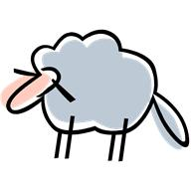 | 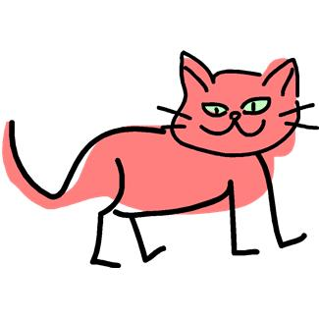
a. sheet  b. sheep  c. ship | a. catt  b. cart  c. cat | a.fish  b.fısh  c.fişh

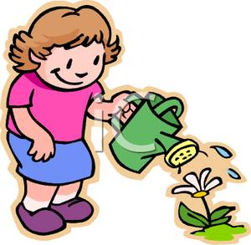
W_t_r fl_w_rs

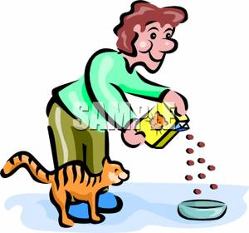
F_ _d _n_m_ls

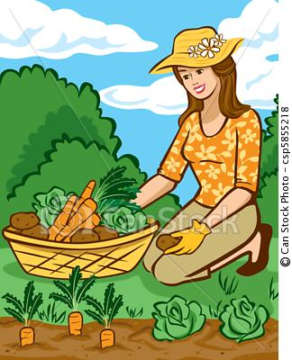
Pl_nt v_g_t_bl_s

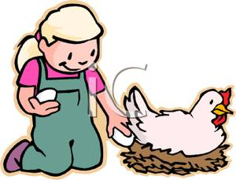
C_ll_ct _ggs

B)DOĞRU OLAN KELİMEYİ İŞARETLEYELİM.
Börd
Bird
Bırd
Cat
Cet
Cad
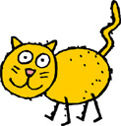
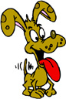
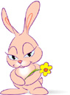
English Teacher
Gizem Şeyda KAYALI
Rabbitt
Rabit
Rabbit
Dog
Doog
Dogg

