2015-2016 EDUCATIONAL YEAR ………………
1ST TERM 1ST ENGLISH EXAM FOR 6TH GRADES
NAME_________________CLASSS_____________NUMBER____________

- Aşağıdaki karşılaştırmaları dağru şekilde doldurunuz. (7x3=21 PUAN)
- Şule is ……………………………….………..….than Seda. (tall)
- Konya is ………………...…………….………. than Afyon. (crowded)
- Elephant is …………..………………..……… than cow. (big)
- Suat is …………………….……………….……. than Kenan. (lazy)
- I phone 6S is ……………..........….………. than Samsung Galaxy S6. ( expensive)
- Our class is ……………………................. than your class. (clean)
- Kıvanç tatlıtuğ is ……………………………..than recep ivedik.(popular)

- Aşağıdaki kelimelerin şıklarını resimlerdeki kutucuklara doğru olarak yazınız.(2x9=18)
a)partly cloudy b)snowy c)rainy d)freezing e)sunny f)windy
g)hot h)stormy i)foggy
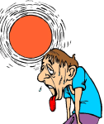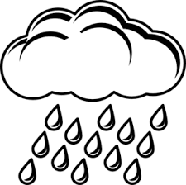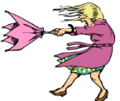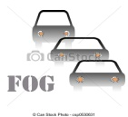

- Aşağıdaki cümleleri doğru şekilde sıralayınız.(3x5=15 PUAN)
- What is the weather like in London?
London 10 C
Rome 32 C
Kiev -5 C

……………………………………………….
- What is the temperature in Rome?

……………………………………………….
- What is the weather like in Kiev?

……………………………………………….

- Aşağıdaki Boşlukları Verilen Kelimelerle Doğru Olacak Şekilde Doldurunuz.(3X8=24)
at present – preparing – doing – not – going-I’m – where – is
1.Student A : What are you ……………….now?
2. Student B : ……………... getting dressed.
3. Student A : What ……….… Jane doing?
4. Student B : She is ……….…….. breakfast
5. Student A : …………..… are you going?
6. Student B : I am ……………. to Gym.
7. Student A: Are you driving fast …………………..?
8. Student B: No, I am …….. driving fast.

E )Aşağıdaki boşlulara gelebilecek olan şıkkı işaretleyiniz.6*2=12P)
- A: Where would you like to live?
B:………………………………………….
a)I am living in Yozgat b)I’d like tol ive in Van c)I like living in Paris d)I am like a giant

- A: ……………………………………….?
B: He is feeding the dog.
a)what is your elder brother doing now? b) what is your favourite food?
c)what are you doing here? d)where is she going?

- A:How do you feel in sunny weather?
B:I feel ……………….
a)anxious b) frightened c) sad d) happy

- A: How does Tommy feel in stormy weather?
B: He …………. sad and angry.
a)feel b)feeling c)feels d)felt

- A) Do you like salami?
B)………………………….
a) no, ı doesnt b)he likes roller coaster
c)it is exciting d)Yes, ı do.

- A) what is your favorite food?
B)……………………………………….
a)ıt is dangerous b)it is rice.
c)ıt is orange juice. d) don’t eat or drink anything

- Aşağıdaki resimlerin altına uygun kelimeyi yazın (10P).
Croissant | Cheese | Orange Juice | Muffin | Milk

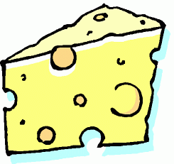 | 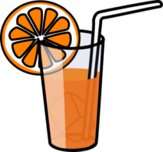 | 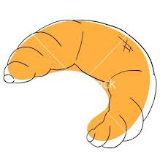 | 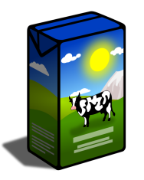 | 