1,2. ve 3. soruları paragrafa göre cevaplayın.


Jenny is fifteen years old.She is from France but she lives in London.Her mother Works as a nurse and her father is a Maths Teacher.She goes to school from 9:00 a.m. to 3:15 p.m.She doesn’t take bus because her father takes her to school.After school she has a snack,she does her homework,she sometımes watches TV.

1.Metne göre hangisi yanlıştır?

A) Jenny goes to school by bus.
B) Jenny is 15 years old.
C) Jenny’s father is a Teacher.
D) She sometimes watches TV.

2. ……… does Jenny Watches TV? –Sometimes.
A) How B) What time C) When D) How often

3. Where does she live? - …………..
A) in France B) in London C) in school D) in home

4. My dad comes home at ………….
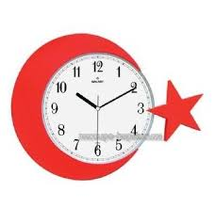
A) half past ten
B) ten to ten
C) ten past ten
D) ten o’clock


5. Sam likes …………………….
A) goıng shoppıng
B) listening to music
C) taking photographs
D) watchıng TV

6. – Does your sister like fast food?
-………………………………

A) Yes,, she does.

B) No, she can’t.
C) Yes,they does
D) Yes, he does.

7. - ……………. is your father’s job?
- He is a farmer.
A) What B) Where C) When D) how

8.What is the day after Sunday?
a) Sunday b)Tuesday
c)Monday d)Wednesday

9. I get up ________6:30 o’clock.
A)on B) in C) under D) at
10. - …………………………?
- I like the blue car.
A) Have you got a car?
B) Where do you drive a car?
C) Which car do you like?
D) Do you like blue cars?
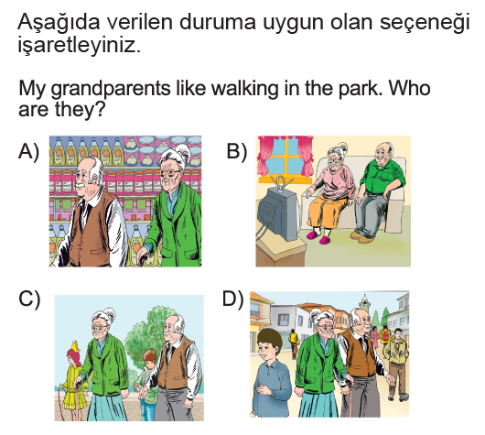
12. Are you a dentist?
Yes, …………….
A) he is B) she is C) I’m D) you are
13. - ………………………..you in the living room?
-No, I ……………………………………
A) Are / am not
B) Can / can’t
C) Have / have
D) Are / am

14. always zaman zarfı cümlede hangi kelimeden sonra kullanılmalıdır?
_John goes to bed early.
A) goes B) John C) bed D) early

15. Emily and Sally …………….. go out in the evenings.
A) don’t B) aren’t C) doesn’t D) isn’t

16. .... do you go to school? - By bus.
A) What B) Where
C) How D) How often

17.
I have ..... in the afternoons.After school.

A) breakfast B) lunch
C) dinner D) snack time

18.
……… a cat like sleeping?
Yes, ...................
A) Do / it does
B) Is / they do
C) Does / it doesn't
D) Does / it does

19. " What does Gamze do in her free time? "
Yukarıdaki sorunun cevabı hangi seçenek olamaz ?
A) She reads story books.
B) She watches television.
C) No, she doesn't have free time.
D) She cooks.


20. Waiter : Would you like some meat sir?
Man : I am a vegetarian. I ................ eat meat .
A) do
B) never
C) always
D) am not

