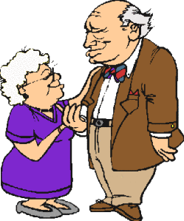
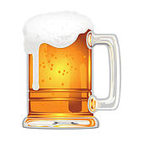
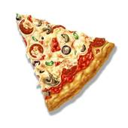

wash take eat drive drink travel visit
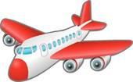
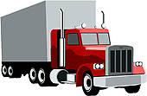
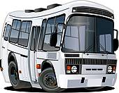

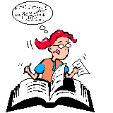
read study
always – often usually
generally – frequently
often – sometimes rarly seldom – never


wear
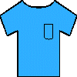

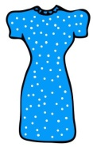
walk
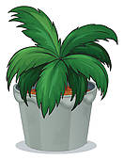
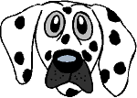
water buy
meet
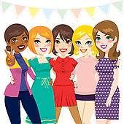

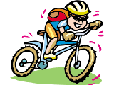
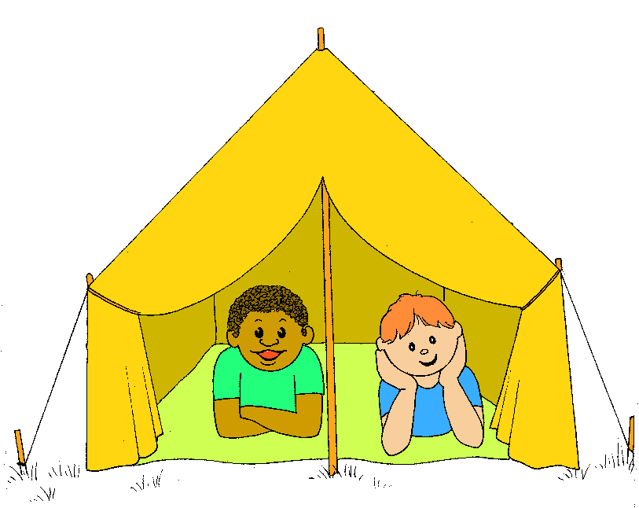
go trow play ride
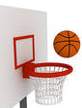
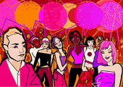

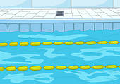

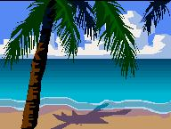
go watch swim

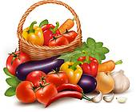

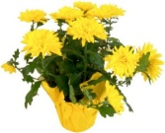
offer give eat

celebrate
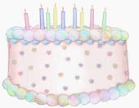
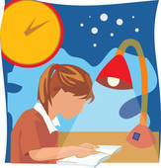
work prepare
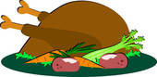
every day / week /month /year
once / twice... a day / a week...

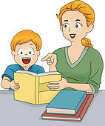
help
build make
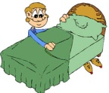
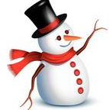

eat listen bake
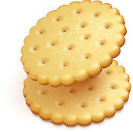
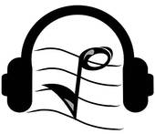
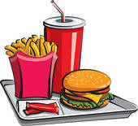

clean speak check pay

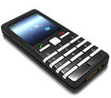
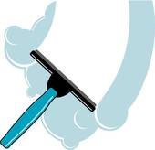
practice
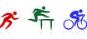

wash your
hair take the eat pizza drive a truck drink beer travel by visit your
bus plane grand
parents

read the study for a
newspaper test
wear a
T-shirt

walk the water the buy a new
dog plant meet friends dress

ride a bike
go camping trow a party play
basket ball

go to the watch TV swim in a
beach pool

offer flowers give eat
chocolates vegetables
always – often usually
generally – frequently
often – sometimes rarly seldom – never

celebrate
work until your prepare
late birthday dinner

help with the
build a make your
snowman homework bed
every day / week /month /year
once / twice... a day / a week...

eat junk listen to bake
food music cookies

practice a clean the speak on check your pay with a
sport window your phone e-mail credit card
Instructions for the teacher

Preparation

- Print the boardgameson tick paper; laminate it so it would last longer.
- Find tokens for each student.( button, beans, stones, candies)
- Provide dices.
- Divide the class into groups of 4 – 5 students each.
- Give each group a boardgame and a dice.
- Give each student a token.
Game
- The players put their tokens on the “start” square.
- The first student throws the dice and moves his token ahead the corresponding number of squares.
- He makes a sentence using the given word and picture, using also a frequency adverb. Ex: I frequently wash my hairs.
- If he gives the correct answer, he stays at the square. If the answer is wrong, he goes back to the previous square.
- The first student who takes a number that places his token on “finish” or surpasses it is the winner.

The first page is meant for students with good enough basic vocabulary. You can use the second page for students with less vocabulary or use it just as an answer sheet.

